GENERAL CONFEDERATION OF LABOR OF VIETNAM

**TON DUC THANG UNIVERSITY**

**FACULTY OF INFORMATION TECHNOLOGY**



**FINAL PROJECT OF ANALYSIS AND DESIGN**

**REQUIRED**

**ONLINE SHOP MANAGEMENT SYSTEM**

*Supervisor:* **M.SC.PHAM THAI KY TRUNG**

*Author*: **NGUYEN LUU TRI – 519H0048**

Class**: 19H50204**

Course **:23**

**HO CHI MINH CITY, 2021**

GENERAL CONFEDERATION OF LABOR OF VIETNAM

**TON DUC THANG UNIVERSITY**

**FACULTY OF INFORMATION TECHNOLOGY**



**FINAL PROJECT OF ANALYSIS AND DESIGN**

**REQUIRED**

**ONLINE SHOP MANAGEMENT SYSTEM**

*Supervisor:*  **M.SC.PHAM THAI KY TRUNG**

*Author*: **NGUYEN LUU TRI – 519H0048**

Class**: 19H50204**

Course **:23**

**HO CHI MINH CITY, 2021**

# APPRECIATION LETTER

First of all, I highly appreciate all the support from M.Sc. Pham Thai Ky Trung. Thank you for all your help to nurture our team will to research and study.

Thank you so much for all knowledges that Ton Duc Thang University provides for us in the last two years so that we are able to finish this assignment completely.

Cannot deny that there are still some mistakes in our assignment but we will never stop improving ourselves to achieve more and more. We hope that our work will be appreciated in the right way and receiving optimistic comments and a right score as it should have.

We sincerely thank you!

**THE ESSAY HAS BEEN CONDUCTED IN TON DUC THANG UNIVERSITY**

I assure that this is my own product and has been guided by M.Sc.Pham Thai Ky Trung. The research contents, results in this topic are all about honesty and this is the first time my essay published as an academic essay. The data in the tables for analysis, comments and evaluation are collected by the me from various sources in the reference section.

In addition, comments and assessments as well as data from other authors or organizations are also used in the essay but with references and annotations.

**If there is any fraud is detected, I ensure my complete responsibility for the contents of my work.** Ton Duc Thang University is not related to violations of authority and copyright caused by me during my work process (if any).

*Ho Chi Minh city, Monday, 10th January. 2022*

*Author*

*(Sign and provide full name)*

*Nguyen Luu Tri*

# VERIFICATION AND EVALUATION FROM LECTURER

**Supervisor’s evaluation**

_______________________________________________________________________________________________________________________________________________________________________________________________________________________________________________________________________________________________________________________________________________________________________________________________________________

Ho Chi Minh city, , . 2022

(Sign and provide full name)

**The assessment of the teacher marked**

_______________________________________________________________________________________________________________________________________________________________________________________________________________________________________________________________________________________________________________________________________________________________________________________________________________

Ho Chi Minh city, , . 2022

(Sign and provide full name)

# TABLE OF CONTENTS

APPRECIATION LETTER iii

VERIFICATION AND EVALUATION FROM LECTURER v

TABLE OF CONTENTS 1

TABLE OF FIGURES 4

TABLE OF TABLES 7

CHAPTER 1: EXECUTIVE SUMMARY 8

CHAPTER 2: BUSINESS REQUIREMENTS 8

**2.1: Organization Chart / Project Chart** 8

**2.2: Business Modelling / Requirements** 9

**2.3: Business Process / Flowchart of Requirements** 10

**2.4: List of Requirements** 10

CHAPTER 3: SYSTEM REQUIREMENT ANALYSIS 12

**3.1: Translate from Business Use Case** 12

**3.1.1: System Narrative** 12

**3.1.2: Users and their goal** 12

**3.1.3: List of Events** 13

**3.1.4: List of Actors** 18

**3.1.5: List of Use Cases** 19

**3.1.6: Use Case Diagram** 21

**3.1.7: Domain Class Model Diagram** 22

**3.2: Use Case Description** 22

**3.2.1: Sign in** 22

**3.2.2: Register** 25

**3.2.3: Change password** 27

**3.2.4: Add product** 29

**3.2.5: Edit product** 32

**3.2.6: Delete product** 35

**3.2.7: Checkout** 38

**3.2.8: Add Cart** 43

**3.2.9: Delete Cart** 46

**3.2.10: Create invoice** 49

**3.2.11: Edit invoice** 52

**3.2.12: Delete invoice** 55

**3.2.13: Add Seller** 58

**3.2.14: Edit Seller** 61

**3.2.15: Delete Seller** 64

**3.2.16: Create Coupon** 67

**3.3: Verifying use cases for Actor** 70

**3.3.1: Verifying uses cases for Administrator** 70

**3.3.2: Verifying uses cases for Manager** 71

**3.3.3: Verifying uses cases for Seller** 71

**3.3.4: Verifying uses cases for Customer** 72

CHAPTER 4: SYSTEM REQUIREMENT DESIGN 73

**4.1: Design Class for Customer Use Cases** 73

**4.1.1: Design Classes in Detailed Design** 73

**4.1.2: Design Class Diagram** 73

**4.1.3: OOD with Communication** 76

**4.1.4: OOD with Sequence Diagram** 76

**4.1.5: Final Design Class Diagram** 76

**4.2: Design Class for Seller Use Cases** 78

**4.2.1: Design Classes in Detailed Design** 78

**4.2.2: Design Class Diagram** 78

**4.2.3: OOD with Communication** 81

**4.2.4: OOD with Sequence Diagram** 82

**4.2.5: Final Design Class Diagram** 83

**4.3: Design Class for Manager Use Cases** 83

**4.3.1: Design Classes in Detailed Design** 83

**4.3.2: Design Class Diagram** 84

**4.3.3: OOD with Communication** 86

**4.3.4: OOD with Sequence Diagram** 86

**4.3.5: Final Design Class Diagram** 87

CHAPTER 5: SYSTEM REQUIREMENT IMPLEMENTATION 87

**5.1: Design Class for Sub System (Use Cases)** 87

**5.2: Package Diagram for Sub System** 88

**5.3: Implementation** 89

**5.3.1:** **Map persistent objects to the tables in a database** 89

**5.3.2:** **Modifying sequence diagrams** 89

**5.3.3:** **UI design** 89

**5.3.4:** **SQL Code** 89

CHAPTER 6: DEMO 94

CHAPTER 7: CONCLUSIONS/RECOMMENDATIONS 94

CHAPTER 8: REFERENCES 94

CHAPTER 9: APPENDIX 95

# TABLE OF FIGURES

Figure 1: Organization Chart of Online Shop System 9

Figure 2: Organization Chart of Online Shop System 10

Figure 3: Use Case Diagram for Online Shop System 21

Figure 4: Domain Class Model Diagram 22

Figure 5: Activity diagram Sign in 24

Figure 6: Sequence diagram Sign in 25

Figure 7: Activity diagram Register 26

Figure 8: Sequence diagram Register 27

Figure 9: Activity diagram Change password 28

Figure 10: Sequence diagram Change password 29

Figure 11: Activity diagram Add product 31

Figure 12: Sequence diagram Add product 32

Figure 13: Activity diagram Edit product 35

Figure 14: Sequence diagram Edit product 35

Figure 15: Activity diagram Delete product 38

Figure 16: Sequence diagram Delete product 38

Figure 17: Activity diagram Checkout 41

Figure 18: Sequence diagram Checkout 43

Figure 19: Activity diagram Add Cart 45

Figure 20: Sequence diagram Add Cart 46

Figure 21: Activity diagram Delete Cart 48

Figure 22: Sequence diagram Delete Cart 49

Figure 23: Activity diagram Create invoice 51

Figure 24: Sequence diagram Create invoice 52

Figure 25: Activity diagram Edit invoice 54

Figure 26: Sequence diagram Edit invoice 55

Figure 27: Activity diagram Delete invoice 57

Figure 28: Sequence diagram Delete invoice 58

Figure 29: Activity diagram Add Seller 60

Figure 30: Sequence diagram Add Seller 61

Figure 31: Activity diagram Edit Seller 63

Figure 32: Sequence diagram Edit Seller 64

Figure 33: Activity diagram Delete Seller 66

Figure 34: Sequence diagram Delete Seller 67

Figure 35: Activity diagram Create Coupon 69

Figure 36: Sequence diagram Create Coupon 70

Figure 37: Design Classes in Detailed Design 73

Figure 38: Domain Design Class 74

Figure 39: Controller 74

Figure 40: UI 74

Figure 41: Data Access 75

Figure 42: Design Class 76

Figure 43: OOD with Communication 76

Figure 44: OOD with Sequence Diagram 76

Figure 45: Final Design Class Diagram 77

Figure 46: Design Classes in Detailed Design 78

Figure 47: Domain Design Class 78

Figure 48: Controller 79

Figure 49 : UI 79

Figure 50: Data Access 80

Figure 51: Design Class 81

Figure 52: OOD with Communication 82

Figure 53: OOD with Sequence Diagram 82

Figure 54 : Final Design Class Diagram 83

Figure 55: Design Classes in Detailed Design 84

Figure 56: Domain Design Class 84

Figure 57: Controller 84

Figure 58: UI 84

Figure 59: Data Access 85

Figure 60: Design Class 85

Figure 61: OOD with Communication 86

Figure 62: OOD with Sequence Diagram 86

Figure 63: Final Design Class Diagram 87

Figure 64: Design Class for Sub System (Use Cases) 88

Figure 65: Package Diagram for Sub System 88

Figure 66: Table Users 89

Figure 67 : Table Customer 89

Figure 68: Table Seller 89

Figure 69: Table Manager 90

Figure 70: Table Product 90

Figure 71: Table Invoice 90

Figure 72: Table Coupon 91

Figure 73: Data of table User 91

Figure 74 : Data of table Customer 91

Figure 75: Data of table Seller 92

Figure 76 : Data of table Manager 92

Figure 77 : Data of table Product 93

Figure 78 : Data of table Invoice 93

Figure 79: Data of table Coupon 94

Figure 80: Full size of use case Diagram 95

Figure 81 : Full size of Class Diagram 96

# TABLE OF TABLES

Table 1: List of requirements 11

Table 2: Table of User and their goals 12

Table 3: Table of List of Event 18

Table 4: Table of List of Actors 18

Table 5: Table of List of Use Cases 20

Table 6: Use Case description Sign in 23

Table 7: Use Case description Register 26

Table 8: Use Case description Change password 28

Table 9: Use Case description Add product 30

Table 10: Use Case description Edit product 33

Table 11: Use Case description Delete product 36

Table 12: Use Case description Checkout 39

Table 13: Use Case description Add Cart 44

Table 14: Use Case description Delete Cart 47

Table 15: Use Case description Create invoice 50

Table 16: Use Case description Edit invoice 53

Table 17: Use Case description Delete invoice 56

Table 18: Use Case description Add Seller 59

Table 19: Use Case description Edit Seller 62

Table 20: Use Case description Delete Seller 65

Table 21: Use Case description Create Coupon 68

Table 22: Verifying uses cases for Administrator 71

Table 23 : Verifying uses cases for Manager 71

Table 24: Verifying uses cases for Seller 72

Table 25: Verifying uses cases for Customer 72

# CHAPTER 1: EXECUTIVE SUMMARY

During the pandemic period, shopping demand has faced many problems due to that fact that their customers could not directly go to stores to purchase, and shops also experienced difficulties when they could not receive customers.

Therefore, our team have created an online fashion store that allows shoppers to access the shop without having to leave their house and for the shop owners easier to find new customers.

The system could perform basic functions such as seller management, product management, purchase management. Add item to cart and delete from cart, check out, and customers could seek support from sellers concerning the product that they’re selling.

# CHAPTER 2: BUSINESS REQUIREMENTS

## **2.1: Organization Chart / Project Chart**

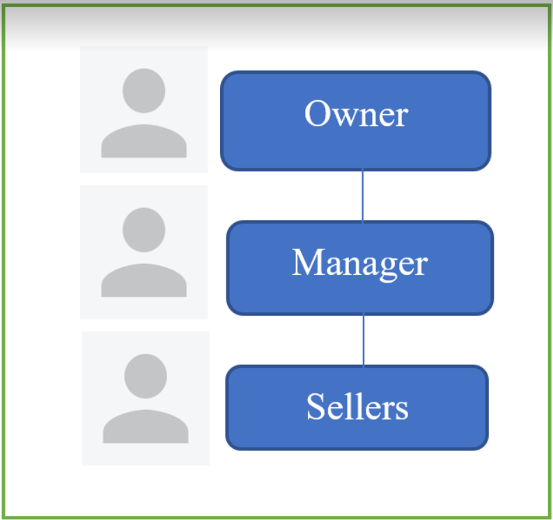

Figure 1: Organization Chart of Online Shop System

## **2.2: Business Modelling / Requirements**

***▼*** *User requirements for the new online shop system*

After consulting with friends and relatives who have lots of experience purchasing goods on the Internet via e-commerce stores, as well as local clothing shop owners, we have identified some of the most important requirements that users would want to have:

♦ User interface must be friendly.

♦ All of the products must be categorized so that they can easily be found.

♦ Not only the payment procedure must be fast but also simple.

♦ It has to support multiple payment methods.

♦ Users could get support from sellers regarding the product that they’re selling.

♦ Sellers could easily add new products to sell or modify old ones.

♦ Managers could access the database to manage the system effortlessly.

*▼ Requirements need to achieve of the online shop system*

♦ The system has to be stable, with little to no errors (if possible).

♦ The search query must return its results quickly and precisely.

♦ Users could find any item fast and accurate.

♦ Backup and restore data required.

## **2.3: Business Process / Flowchart of Requirements**

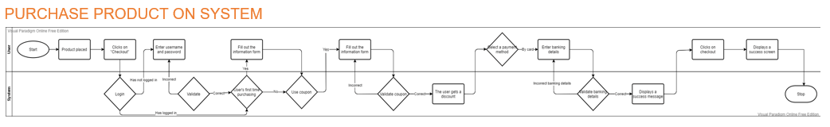

Figure 2: Organization Chart of Online Shop System

## **2.4: List of Requirements**

|  |  |  |
| --- | --- | --- |
| Requirments | Functional | Nonfunctional |
| User-friendly interface |  | X |
| Administrators could access all parts of the system | X |  |
| Administrators could backup and restore system data | X |  |
| Users could sign in | X |  |
| Managers could add, edit or delete employees | X |  |
| Employees could add, edit, or delete products | X |  |
| Employees could create invoices, coupons, verify transactions | X |  |
| Employees could manage sales summary | X |  |
| Customers could search for products | X |  |
| Customers could add or delete products in their cart | X |  |
| Customers could confirm and change their shipping address | X |  |
| Customers could choose COD or credit card payment and add coupons to receive a discount | X |  |
| The search query must return its results quickly and precisely | X |  |
| All of the products must be categorized so that they can easily be found | X |  |

Table 1: List of requirements

# CHAPTER 3: SYSTEM REQUIREMENT ANALYSIS

## **3.1: Translate from Business Use Case**

### **3.1.1: System Narrative**

Add product to cart and checkout progress:

+ Customer first come to the system in order to purchase products first have to register an account. After that choose the product they want to see then click "Add to Cart", a message "Added successfully" will appear. Then click the Cart icon to see what products is in it, if customer want to remove a product click delelte, a message "Deleted successfully" will appear. Then click checkout and move to the checkout page. Here, customer can choose which paid method they prefer (COD, banking) and they can apply coupon if they have one. After confirm the shipping address, customer click button "Finish" and will be moved to the invoice page with message "Checkout successfully".

+ The manager will manage the sellers who manage the customers purchasing process.

+ And so that users can use their rights in the system thanks to the maangemantof the administrator.

### **3.1.2: Users and their goal**

|  |  |
| --- | --- |
| User | User's goal |
| Admin | System management  +Backup and restore data  +User management |
| Manager | Seller management |
| Seller | -Product management  -Transaction management  +Create invoices and confirm shipping address  +Create coupon  -Sales summary |
| Customer | -Choose products  -Checkout |

Table 2: Table of User and their goals

### **3.1.3: List of Events**

|  |  |  |  |  |  |
| --- | --- | --- | --- | --- | --- |
| Event | Trigger | Source | Use Case | Response | Destination |
| Administrator  wants to control  the system | System inquiry | Administrator | System management | System control | Administrator |
| Administrator  wants to backup  and restore data | Backup and  restore | Administrator | Backup and  Restore data | Data saved | System |
| Administrator  wants to mange  the user who  interact with the  system | User  management  inquiry | Administrator | User  management | Information of  the users | Administrator |
| Seller  wants to view  information of  the product. | Information of  products | Seller | Product  management | Information of  the products | Seller |
| Seller  wants to add new  product into the  system. | Add product | Seller | Add product | Information  saved | Seller |
| Seller  wants to edit new  product into the  system. | Update  information of  the product | Seller | Edit product | Information  updated | Seller |
| Seller  wants to delete new  product into the  system. | Delete product | Seller | Delete product | Data updated | Seller |
| Seller  wants to search a  product quickly. | Search detail | Seller | Search product | Result | Seller |
| Seller  wants to view  information of  the transaction. | Transaction  inquiry | Seller | Transaction management | Information of  the transactions | Seller |
| Seller  wants to create an invoice | Create invoice | Seller | Create invoice | Information  saved | Seller |
| Seller  wants to edit an invoice | Update  information of  the invoice | Seller | Edit invoice | Information  updated | Seller |
| Seller  wants to delete an invoice | Delete invoice | Seller | Delete invoice | Data  saved | Seller |
| Seller  wants to search an  invoice quickly. | Search detail | Seller | Search invoice | Result | Seller |
| Seller  wants to create a coupon | Create coupon | Seller | Create coupon | Information  saved | Seller |
| Seller  wants to view  information of  the sale summary. | Information of  sale summary | Seller | Sale summary | Information of  the sale summary | Seller |
| Manager  wants to view  information of  the seller. | Information of  sellers | Manager | Seller management | Information of  the seller | Manager |
| Manager  wants to add a seller | Add seller | Manager | Add seller | Information  saved | Manager |
| Manager  wants to edit a seller | Update  information of  the seller | Manager | Edit seller | Information  updated | Manager |
| Manager  wants to delete a seller | Delete seller | Manager | Delete seller | Data  saved | Manager |
| Manager  wants to search an  seller quickly. | Search  detail | Manager | Search seller | Result | Manager |
| Customer  wants to view  information of  the product. | Information of  product | Customer | Choose product | Information of  product | Customer |
| Customer  wants to add product to cart. | Add product to cart | Customer | Add product | Add product success | Customer |
| Customer  wants to delete product from cart. | Delete product from cart | Customer | Deleter product | Delete product success | Customer |
| Customer want to checkout | Checkout information | Customer | Checkout | Checkout information | Customer |
| Customer want to choose payment method | Payment information | Customer | Pay bill | Choose payment method (COD/banking) | Customer |
| Regular customer want to add coupon | Coupon detail | Customer | Add coupon | Add coupon success | Customer |
| Customer want to confirm shipping information | Shipping information | Customer | Checkout | Confirm shipping information | Customer  Seller |
| Customer want to edit shipping information | Update  information of  shipping | Customer | Edit shipping info | Information  updated | Customer |
| Users want  to sign into the  system. | User detail | Management  Seller  Customer | Sign in | Success | Management  Seller  Customer |
| Users want  to registration a new account. | User detail | Management  Seller  Customer | Sign up | Success | Management  Seller  Customer |
| Users want  to log out the  system. | User detail | Management  Seller  Customer | Sign out | Success | Management  Seller  Customer |
| Users forget  the password so  the user want to  change password. | User detail | Management  Seller  Customer | Information saved | Success | Management  Seller  Customer |

Table 3: Table of List of Event

### **3.1.4: List of Actors**

|  |  |
| --- | --- |
| Actors | Meaning |
| Admin | Administrators could access all parts of the system and modify it as they please. |
| Manager | Managers could supervise one or many sellers. |
| Seller | Sellers could manage their selling products, communicate with customers, create invoices and manage the sales. |
| Customer | Customers could choose products and checkout. |

Table 4: Table of List of Actors

### **3.1.5: List of Use Cases**

|  |  |
| --- | --- |
| USE CASE | MEANING |
| System management | Allow the administrator to control the system. |
| Backup and restore data | Allow the administrator to perform backup and restore data. Data is saved by file. |
| User management | Allow the administrator to manage the users who interact with the system. |
| User management | Allow the administrator to manage the users who  interact with the system. |
| Product management | Allow the seller to manage information of the products. |
| Add product | Allow the seller to add new product into the system. |
| Edit product | Allow the seller to edit information of the products. |
| Delete product | Allow the seller to delete the product. |
| Search product | Allow to search product quickly. |
| Transaction management | Allow the seller to manage information of the transactions. |
| Create invoice | Allow the seller to ceate a new invoice. |
| Edit invoice | Allow the seller to edit information of the invoice. |
| Delete invoice | Allow the seller to delete the invoice. |
| Search invoice | Allow to search invoice quickly. |
| Create coupon | Allow the seller to ceate a new coupon for customer who bought more than 2 times. |
| Sales sumamry | Allow the seller to view sales summary daily, mothly and yearly. |
| Seller management | Allow the manager to manage information of the products. |
| Add seller | Allow the manager to add new seller into the system. |
| Edit seller | Allow the manager to edit information of the seller. |
| Delete seller | Allow the manager to delete the seller. |
| Search seller | Allow to search seller quickly. |
| Choose product | Allow customer to view products |
| Add to cart | Allow customer to add products to cart |
| Delete from cart | Allow customer to remove products to cart |
| Checkout | Allow to checkout |
| Pay bill | Allow customer to choose payment method |
| COD | Allow customer to COD(Change of Destination) method |
| ATM/creditCard | Allow customer to use banking method |
| Add coupon | Allow regular customer to add coupon |
| Confirm shipping info | Allow customer to confirm the shipping information |
| Edit shipping info | Allow customer to edit the shipping information |
| Sign in | Allow the user sign into the system. |
| Sign up | Allow the user to create an account to sign in into the system. |
| Sign out | Allow the user to log out the system. |
| Change password | Allow the user to change password when they forget. |

Table 5: Table of List of Use Cases

### **3.1.6: Use Case Diagram**

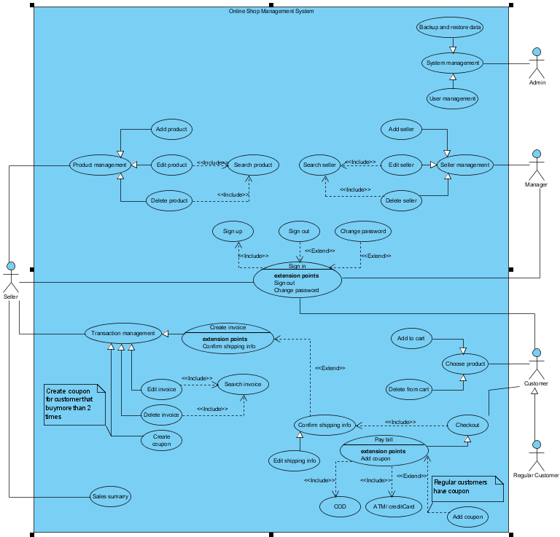

Figure 3: Use Case Diagram for Online Shop System

### **3.1.7: Domain Class Model Diagram**

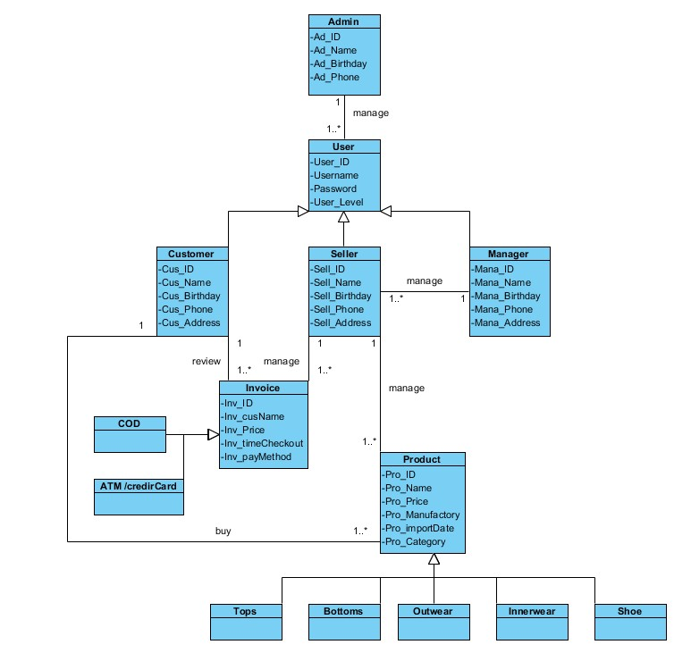

Figure 4: Domain Class Model Diagram

## **3.2: Use Case Description**

### **3.2.1: Sign in**

|  |  |  |
| --- | --- | --- |
| **Use Case ID** | UC-1 | |
| **Use Case Name** | Sign in | |
| **Scenario** | Allows user to sign in using name and password | |
| **Actor(s)** | User, System | |
| **Priority** | Must have | |
| **Trigger** | User enter their name and password then click the login button | |
| **Pre-Condition(s)** | * User can and have access to the app | |
| **Post-Condition(s)** | * If the name and password are correct, user can go to the main screen after click the login button | |
| **Flow of activities** | Actor | System |
| 1. User enter their name and password  2. User click the login button | 2.1 Check the name and password information on the database  2.2 If correct show the main application screen  2.3 If wrong ask user to re-enter name and password |
| **Non-Functional Requirement** | * The system must check quickly, without errors * System response to user must be quick | |

Table 6: Use Case description Sign in

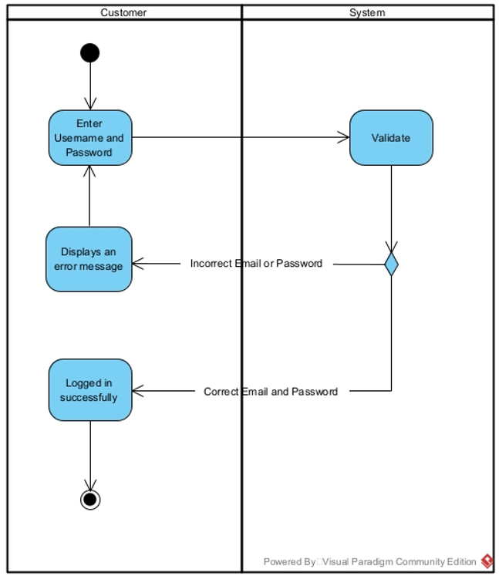

Figure 5: Activity diagram Sign in

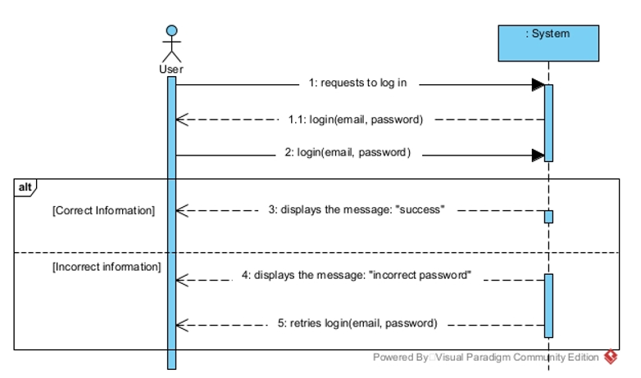

Figure 6: Sequence diagram Sign in

### **3.2.2: Register**

|  |  |  |
| --- | --- | --- |
| **Use Case ID** | UC-2 | |
| **Use Case Name** | Register | |
| **Scenario** | Allows user register their new account before access to the system | |
| **Actor(s)** | User, System | |
| **Priority** | Must have | |
| **Trigger** | User click the register button | |
| **Pre-Condition(s)** | * User don't have an account to access to the system | |
| **Post-Condition(s)** | * User have their own account to login to the system | |
| **Flow of activities** | Actor | System |
| 1. User click the register button  2. User enter their name, id and password | 1.1 Show the register screen  2.1 Check the name, id and password information on the database  2.2 If the id is not used then show register success message  2.3 If the id has been used then show re-enter name message |
| **Non-Functional Requirement** | * The system must run quickly, without errors * System response to user must be quick | |

Table 7: Use Case description Register

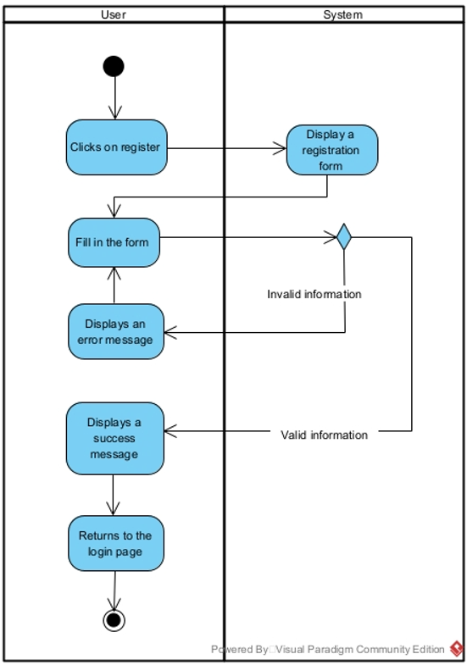

Figure 7: Activity diagram Register

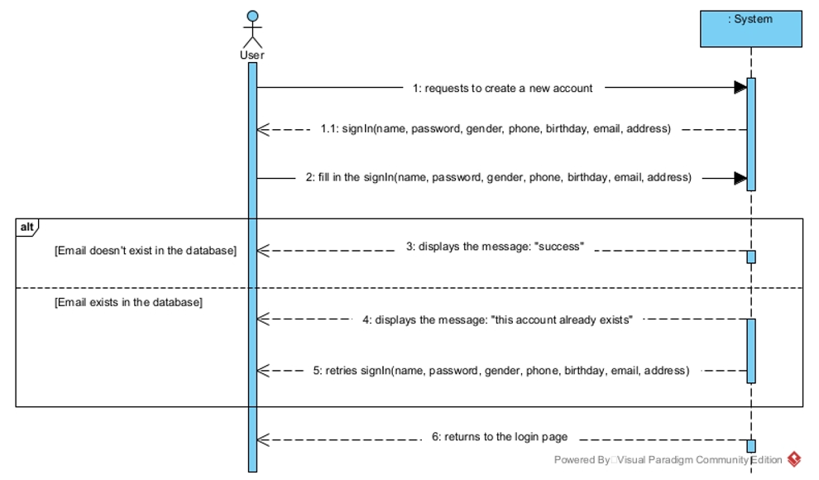

Figure 8: Sequence diagram Register

### **3.2.3: Change password**

|  |  |  |
| --- | --- | --- |
| **Use Case ID** | UC-3 | |
| **Use Case Name** | Change password | |
| **Scenario** | User forgot and want to change their password | |
| **Actor(s)** | User, System | |
| **Priority** | Must have | |
| **Trigger** | User click the "forgot password?" line | |
| **Pre-Condition(s)** | * User want to change password | |
| **Post-Condition(s)** | * The new password has been set | |
| **Flow of activities** | Actor | System |
| 1. User click the "forgot password?" line  2. User enter their name and id  3. User enter the new password | 1.1 System show the change password screen  2.1 Check the name and id information on the database  2.2 If correct show the new password screen  2.3 If not correct show the re-enter name or id message  3.1 Save the new password |
| **Non-Functional Requirement** | * The system must run quickly, without errors * System response to user must be quick | |

Table 8: Use Case description Change password

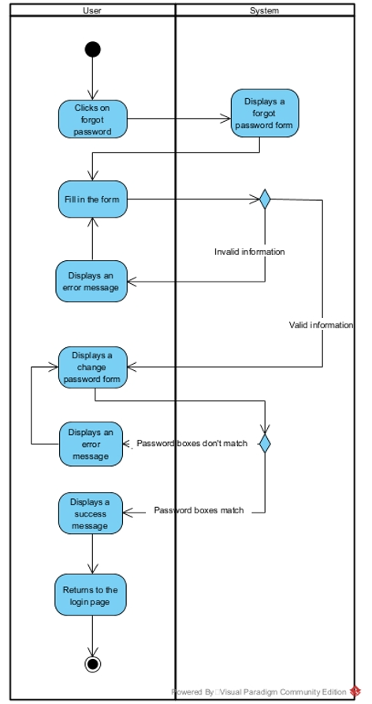

Figure 9: Activity diagram Change password

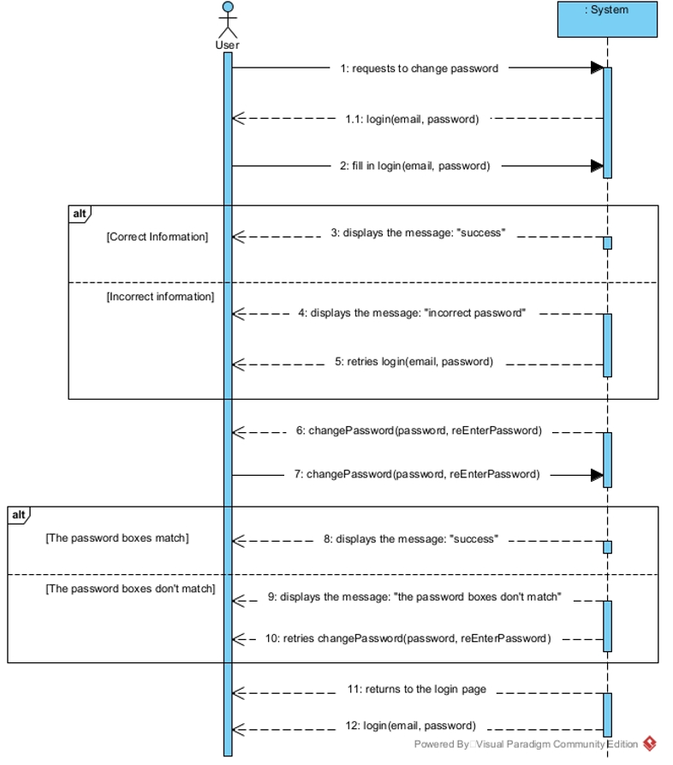

Figure 10: Sequence diagram Change password

### **3.2.4: Add product**

|  |  |  |
| --- | --- | --- |
| **Use Case ID** | UC-4 | |
| **Use Case Name** | Add product | |
| **Scenario** | Seller adds new products to the system | |
| **Actor(s)** | Seller, System | |
| **Priority** | Must have | |
| **Trigger** | Seller clicks on the "add product" button | |
| **Pre-Condition(s)** | 1. Seller wants to add new products | |
| **Post-Condition(s)** | * The product is successfully added on the system | |
| **Flow of activities** | Actor | System |
| 1. Seller clicks on the "add product" button  2. Seller enters the product’s information | 1.1 System show the product information screen  2.1 System saves the new product on the database and show "successfully added" message |
| **Non-Functional Requirement** | * The system must run quickly, without errors * System response to user must be quick | |

Table 9: Use Case description Add product

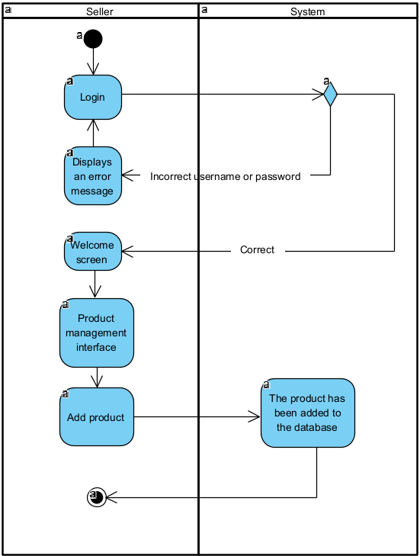

Figure 11: Activity diagram Add product

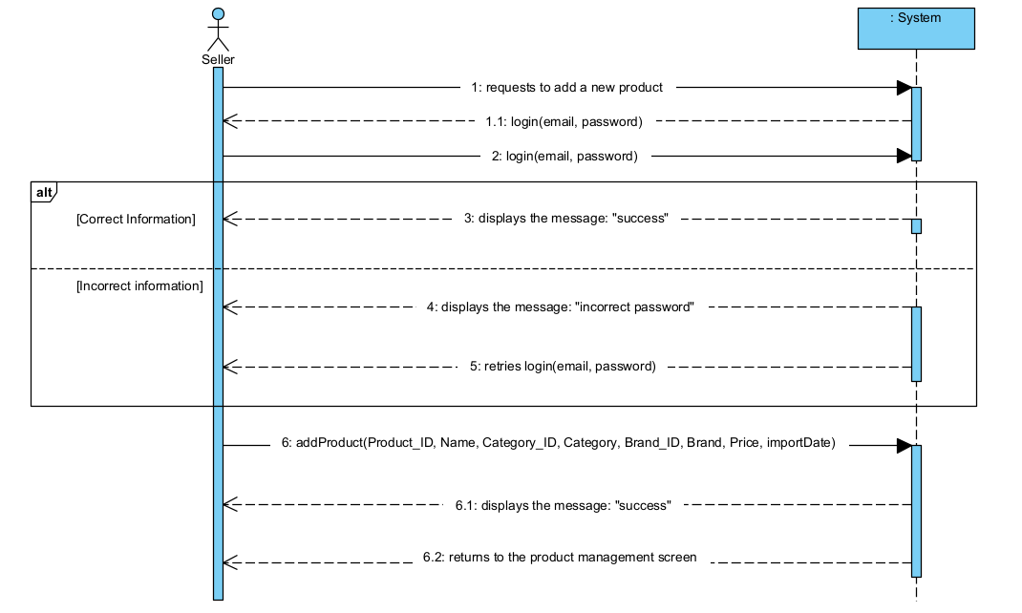

Figure 12: Sequence diagram Add product

### **3.2.5: Edit product**

|  |  |  |
| --- | --- | --- |
| **Use Case ID** | UC-5 | |
| **Use Case Name** | Edit product | |
| **Scenario** | Seller edits an existing product on the system | |
| **Actor(s)** | Seller, System | |
| **Priority** | Must have | |
| **Trigger** | Seller clicks on the "edit product" button | |
| **Pre-Condition(s)** | 1. Seller wants to update information of a product | |
| **Post-Condition(s)** | * The product is successfully updated on the system | |
| **Flow of activities** | Actor | System |
| 1. Seller clicks on the "edit product" button  2. Seller enters the product’s new information | 1.1 System show the product information screen  2.1 System shows the "successfully updated" message |
| **Non-Functional Requirement** | * The system must run quickly, without errors * System response to user must be quick | |

Table 10: Use Case description Edit product

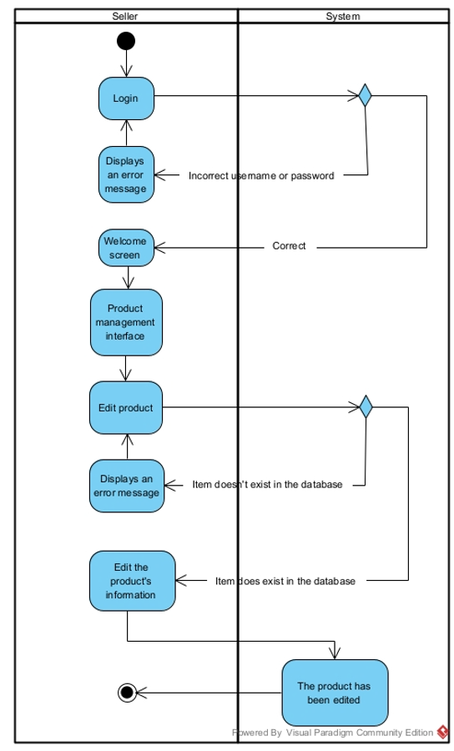

Figure 13: Activity diagram Edit product

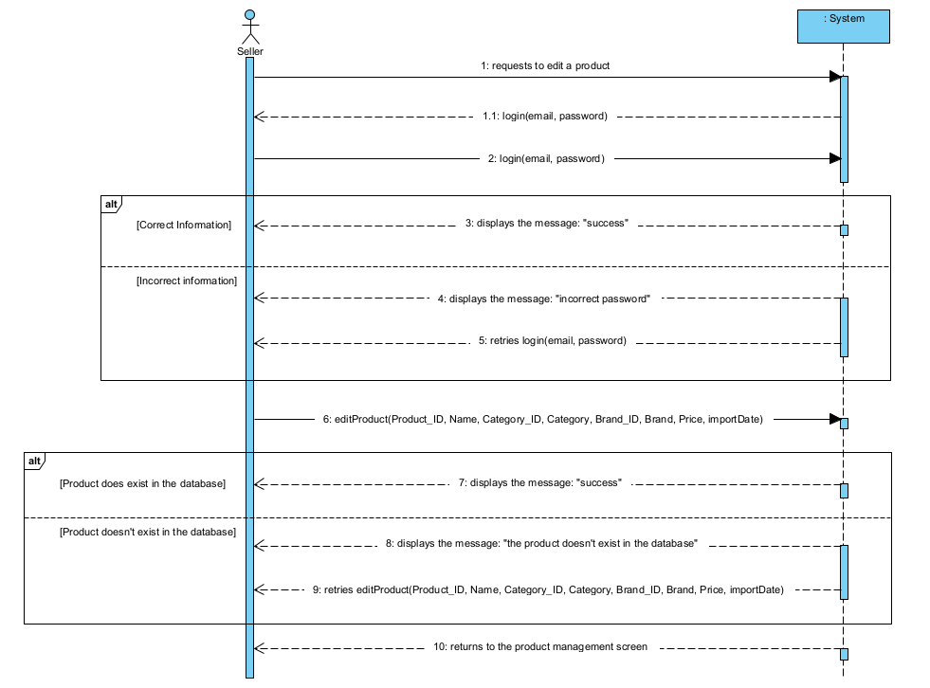

Figure 14: Sequence diagram Edit product

### **3.2.6: Delete product**

|  |  |  |
| --- | --- | --- |
| **Use Case ID** | UC-6 | |
| **Use Case Name** | Delete product | |
| **Scenario** | Seller deletes an existing product on the system | |
| **Actor(s)** | Seller, System | |
| **Priority** | Must have | |
| **Trigger** | Seller clicks on the "delete product" button | |
| **Pre-Condition(s)** | 1. Seller wants to delete a product | |
| **Post-Condition(s)** | * The product is successfully deleted from the system | |
| **Flow of activities** | Actor | System |
| 1. Seller clicks on the "delete product" button | 1.1 System show the product information screen  1.2 System shows the "successfully deleted" message |
| **Non-Functional Requirement** | * The system must run quickly, without errors * System response to user must be quick | |

Table 11: Use Case description Delete product

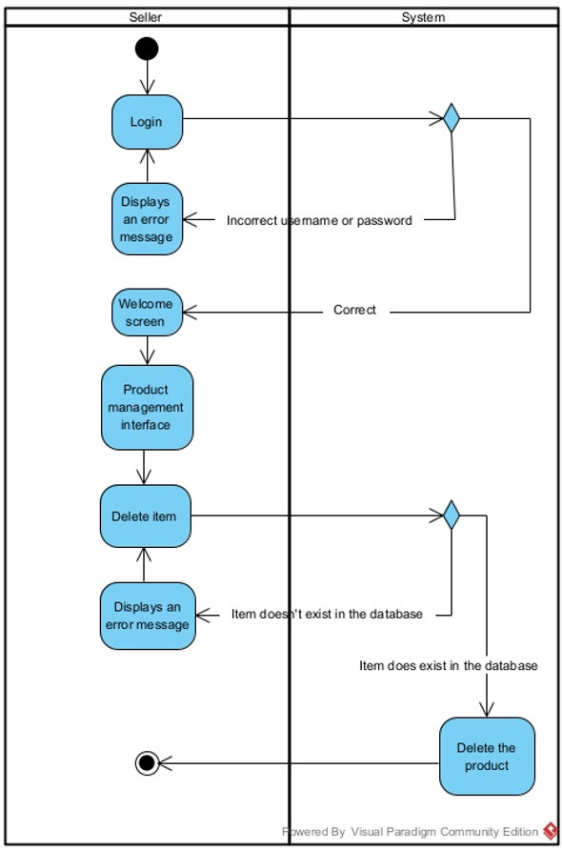

Figure 15: Activity diagram Delete product

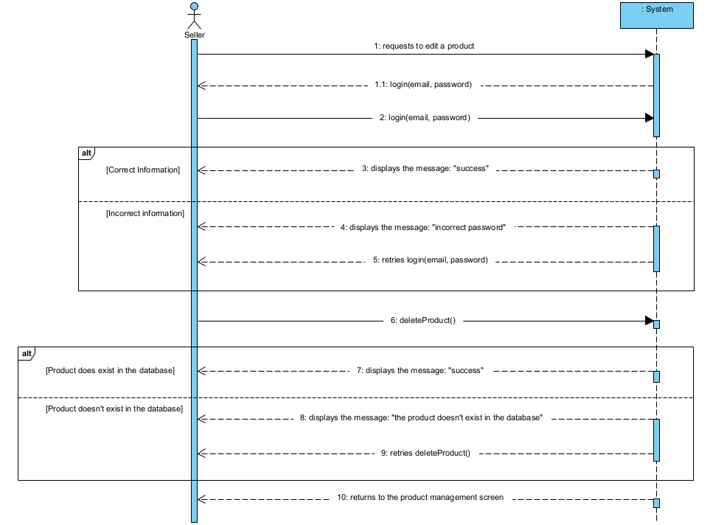

Figure 16: Sequence diagram Delete product

### **3.2.7: Checkout**

|  |  |  |
| --- | --- | --- |
| **Use Case ID** | UC-7 | |
| **Use Case Name** | Checkout | |
| **Scenario** | Allows the user various options to pay for the product(s). | |
| **Actor(s)** | User, System | |
| **Priority** | Must have | |
| **Trigger** | The user clicks on the “checkout” button | |
| **Pre-Condition(s)** | * The user must have at least one product in their cart | |
| **Post-Condition(s)** | * The product(s) will be ordered and transported to the user | |
| **Flow of activities** | Actor | System |
| 1. The user clicks on the “checkout” button  2. The user can choose to log in or not  3. If the user is not logged in or this is their first purchase, prompts them to fill out their shipping address and payment method | 1.1 Shows the edit product screen  2.1 Displays the log in screen  3.1. Validates the given information and updates it into the database  3.2. Orders the product(s) and transports it/them to the user |
| **Non-Functional Requirement** | * The system must run quickly, without errors * System response to user must be quick | |

Table 12: Use Case description Checkout

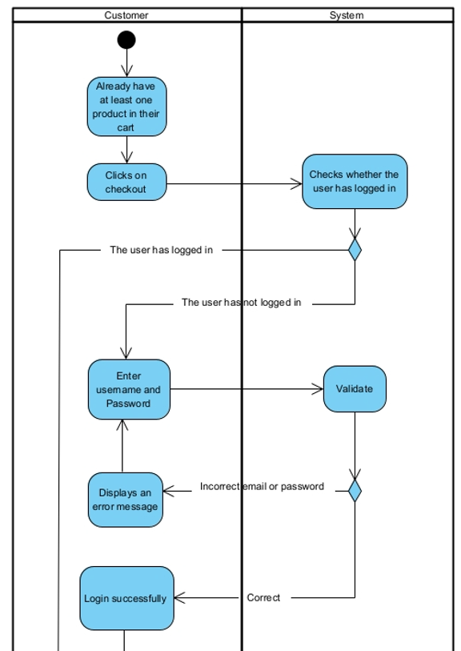

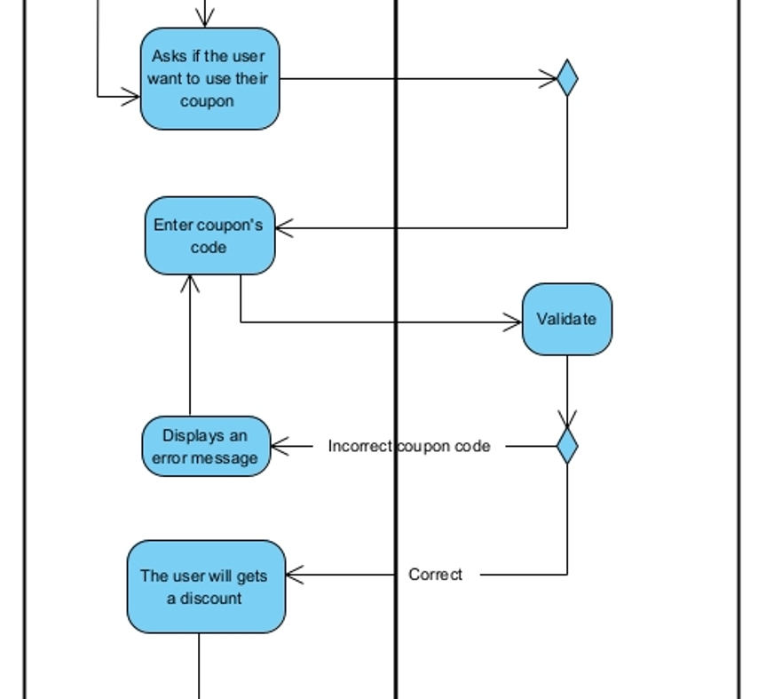

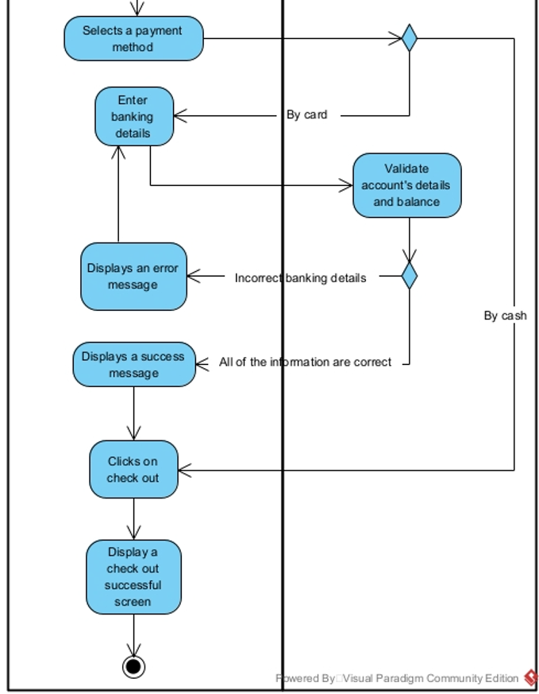

Figure 17: Activity diagram Checkout

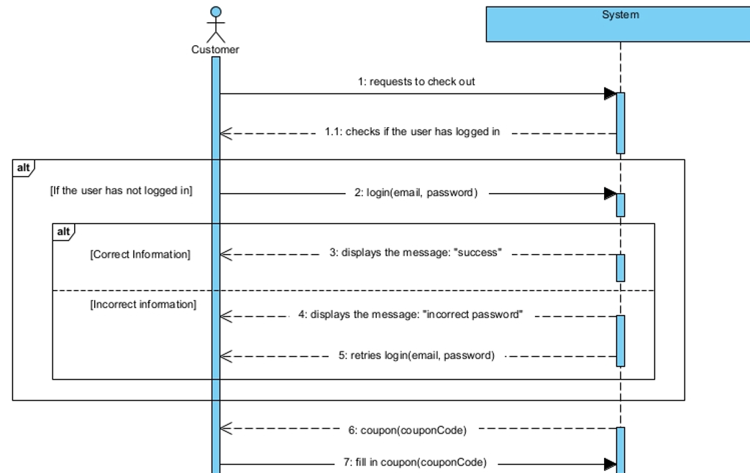

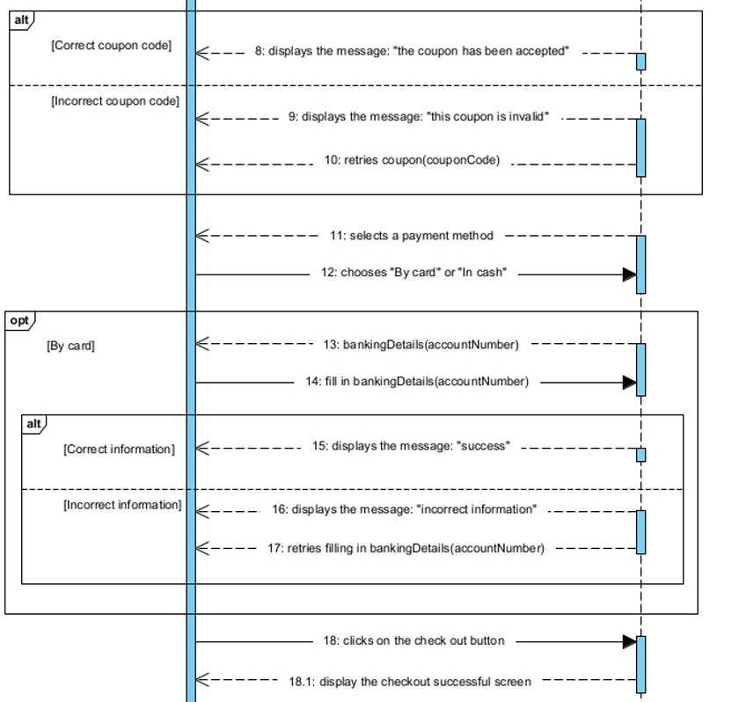

Figure 18: Sequence diagram Checkout

### **3.2.8: Add Cart**

|  |  |  |
| --- | --- | --- |
| **Use Case ID** | UC-8 | |
| **Use Case Name** | Add Cart | |
| **Scenario** | Customers add new products to their cart | |
| **Actor(s)** | Customer, System | |
| **Priority** | Must have | |
| **Trigger** | Customer clicks on the "add product to cart" button | |
| **Pre-Condition(s)** | 1. Customer wants to add new products to their cart | |
| **Post-Condition(s)** | * The product is successfully added to their cart | |
| **Flow of activities** | Actor | System |
| 1. Customer clicks on the " add product to cart " button | 1.1 System adds the product into customer’s cart |
| **Non-Functional Requirement** | * The system must run quickly, without errors * System response to user must be quick | |

Table 13: Use Case description Add Cart

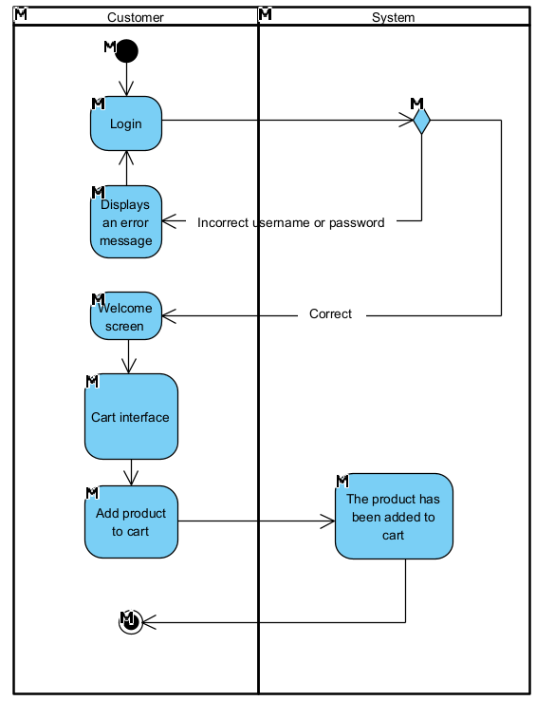

Figure 19: Activity diagram Add Cart

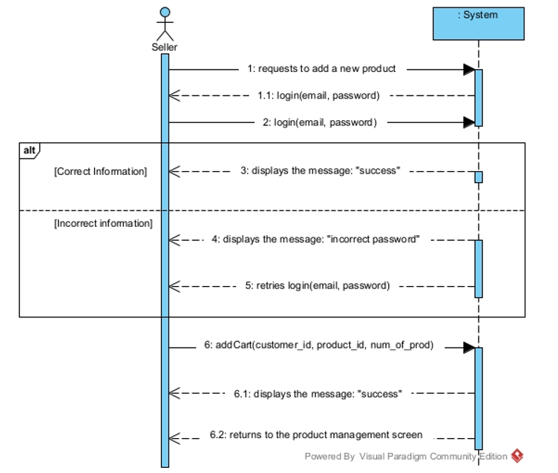

Figure 20: Sequence diagram Add Cart

### **3.2.9: Delete Cart**

|  |  |  |
| --- | --- | --- |
| **Use Case ID** | UC-9 | |
| **Use Case Name** | Add product | |
| **Scenario** | Seller adds new products to the system | |
| **Actor(s)** | Seller, System | |
| **Priority** | Must have | |
| **Trigger** | Seller clicks on the "add product" button | |
| **Pre-Condition(s)** | 1. Seller wants to add new products | |
| **Post-Condition(s)** | * The product is successfully added on the system | |
| **Flow of activities** | Actor | System |
| 1. Seller clicks on the "add product" button  2. Seller enters the product’s information | 1.1 System show the product information screen  2.1 System saves the new product on the database and show "successfully added" message |
| **Non-Functional Requirement** | * The system must run quickly, without errors * System response to user must be quick | |

Table 14: Use Case description Delete Cart

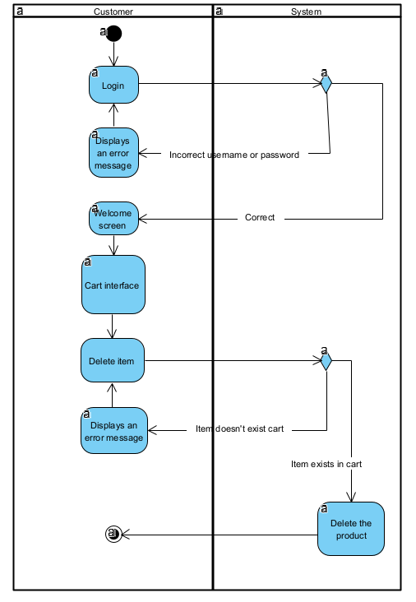

Figure 21: Activity diagram Delete Cart

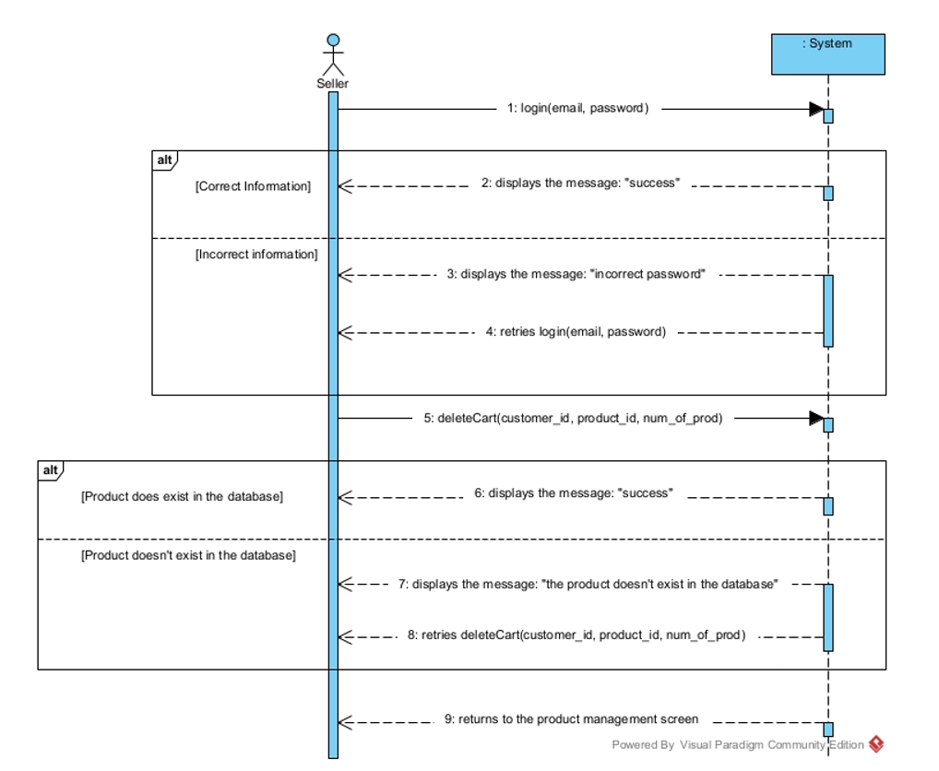

Figure 22: Sequence diagram Delete Cart

### **3.2.10: Create invoice**

|  |  |  |
| --- | --- | --- |
| **Use Case ID** | UC-10 | |
| **Use Case Name** | Create invoice | |
| **Scenario** | Seller creates a new invoice | |
| **Actor(s)** | Seller, System | |
| **Priority** | Must have | |
| **Trigger** | Seller clicks on the "create invoice" button | |
| **Pre-Condition(s)** | * Seller wants to create an invoice | |
| **Post-Condition(s)** | * The invoice is successfully created | |
| **Flow of activities** | Actor | System |
| 1. Seller clicks on the "create invoice" button  2. Seller enters the invoice’s information | 1.1 System shows the invoice generating screen  2.1 System creates a new invoice and show "successfully created" message |
| **Non-Functional Requirement** | * The system must run quickly, without errors * System response to user must be quick | |

Table 15: Use Case description Create invoice

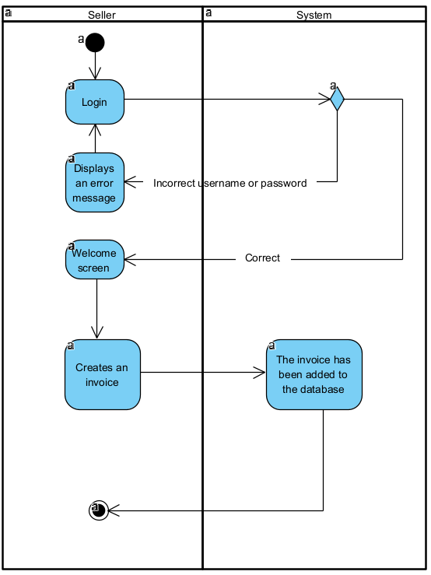

Figure 23: Activity diagram Create invoice

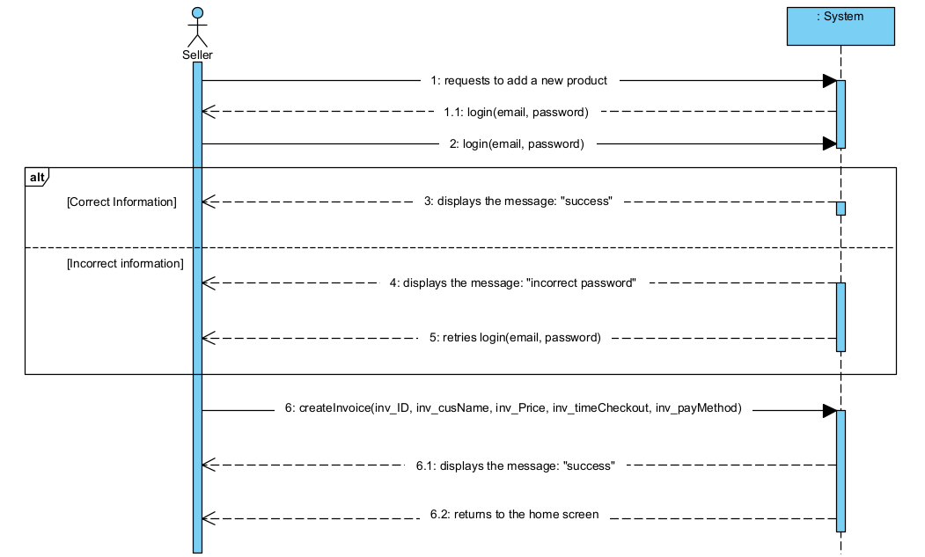

Figure 24: Sequence diagram Create invoice

### **3.2.11: Edit invoice**

|  |  |  |
| --- | --- | --- |
| **Use Case ID** | UC-11 | |
| **Use Case Name** | Edit invoice | |
| **Scenario** | Seller edits an invoice | |
| **Actor(s)** | Seller, System | |
| **Priority** | Must have | |
| **Trigger** | Seller clicks on the "edit invoice" button | |
| **Pre-Condition(s)** | * Seller wants to update information of an invoice | |
| **Post-Condition(s)** | * The invoice is successfully updated on the system | |
| **Flow of activities** | Actor | System |
| 1. Seller clicks on the "edit invoice" button  2. Seller enters the invoice’s new information | 1.1 System show the invoice information screen  2.1 System shows the "successfully updated" message |
| **Non-Functional Requirement** | * The system must run quickly, without errors * System response to user must be quick | |

Table 16: Use Case description Edit invoice

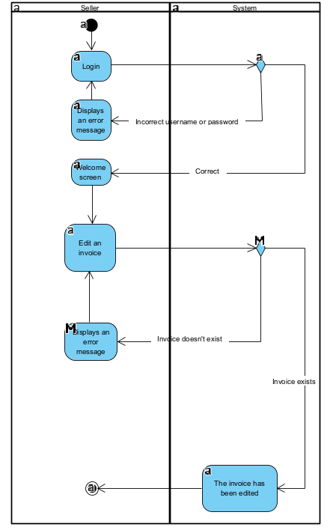

Figure 25: Activity diagram Edit invoice

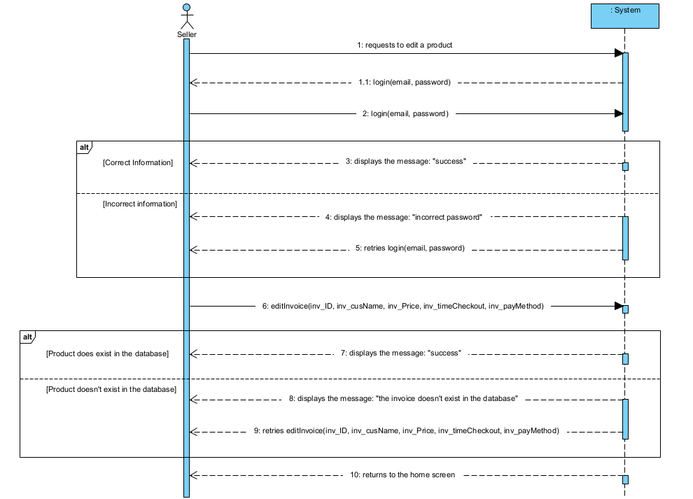

Figure 26: Sequence diagram Edit invoice

### **3.2.12: Delete invoice**

|  |  |  |
| --- | --- | --- |
| **Use Case ID** | UC-12 | |
| **Use Case Name** | Delete invoice | |
| **Scenario** | Seller deletes an invoice | |
| **Actor(s)** | Seller, System | |
| **Priority** | Must have | |
| **Trigger** | Seller clicks on the "delete product" button | |
| **Pre-Condition(s)** | * Seller wants to delete an invoice | |
| **Post-Condition(s)** | * The invoice is successfully deleted from the system | |
| **Flow of activities** | Actor | System |
| 1. Seller clicks on the "delete invoice" button | 1.1 System shows the invoice information screen  1.2 System shows the "successfully deleted" message |
| **Non-Functional Requirement** | * The system must run quickly, without errors * System response to user must be quick | |

Table 17: Use Case description Delete invoice

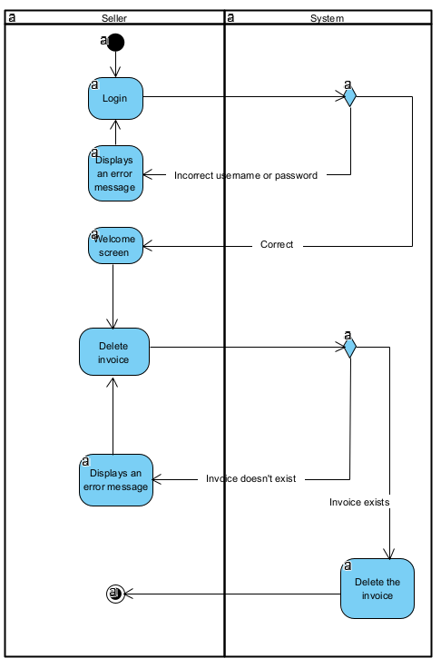

Figure 27: Activity diagram Delete invoice

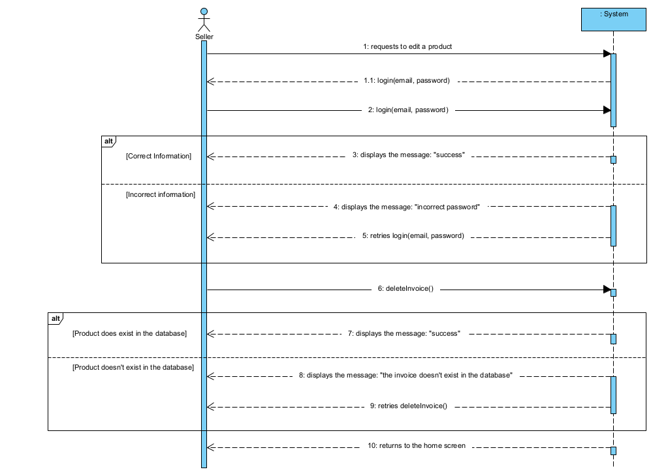

Figure 28: Sequence diagram Delete invoice

### **3.2.13: Add Seller**

|  |  |  |
| --- | --- | --- |
| **Use Case ID** | UC-13 | |
| **Use Case Name** | Add seller | |
| **Scenario** | Manager wants to add new sellers | |
| **Actor(s)** | Manager, System | |
| **Priority** | Must have | |
| **Trigger** | Manager clicks on the "add seller" button | |
| **Pre-Condition(s)** | * Manager wants to add new sellers | |
| **Post-Condition(s)** | * The seller is successfully added on the system | |
| **Flow of activities** | Actor | System |
| 1. Manager clicks on the "add seller" button  2. Manager enters the seller’s information | 1.1 System show the seller’s information screen  2.1 System saves the new seller on the database and show "successfully added" message |
| **Non-Functional Requirement** | * The system must run quickly, without errors * System response to user must be quick | |

Table 18: Use Case description Add Seller

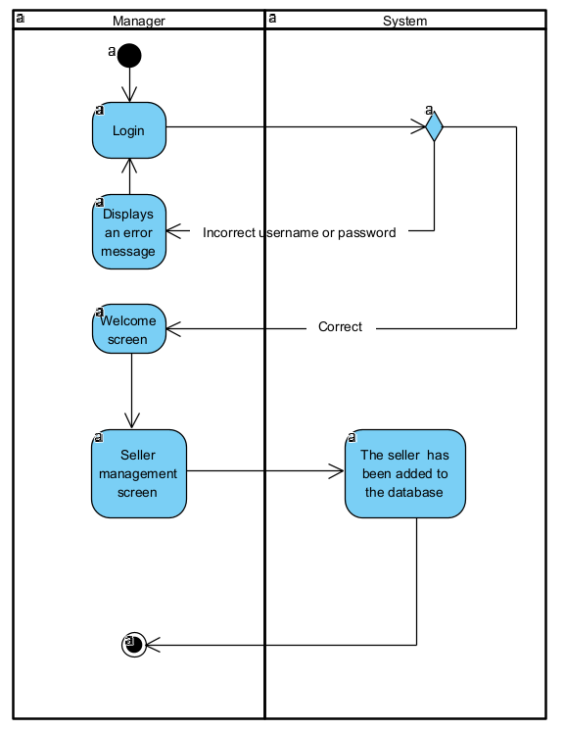

Figure 29: Activity diagram Add Seller

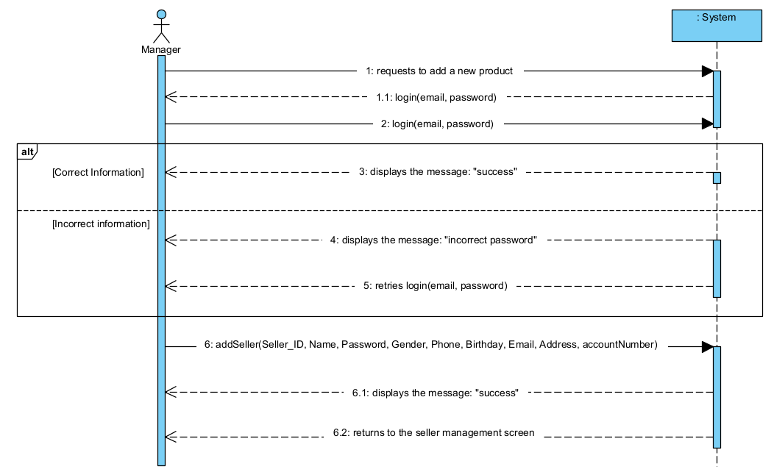

Figure 30: Sequence diagram Add Seller

### **3.2.14: Edit Seller**

|  |  |  |
| --- | --- | --- |
| **Use Case ID** | UC-14 | |
| **Use Case Name** | Edit seller | |
| **Scenario** | Manager edits an existing seller on the system | |
| **Actor(s)** | Manager, System | |
| **Priority** | Must have | |
| **Trigger** | Manager clicks on the "edit seller" button | |
| **Pre-Condition(s)** | * Manager wants to update information of a seller | |
| **Post-Condition(s)** | * The seller is successfully updated on the system | |
| **Flow of activities** | Actor | System |
| 1. Manager clicks on the "edit seller" button  2. Manager enters the seller’s new information | 1.1 System show the seller’s information screen  2.1 System shows the "successfully updated" message |
| **Non-Functional Requirement** | * The system must run quickly, without errors * System response to user must be quick | |

Table 19: Use Case description Edit Seller

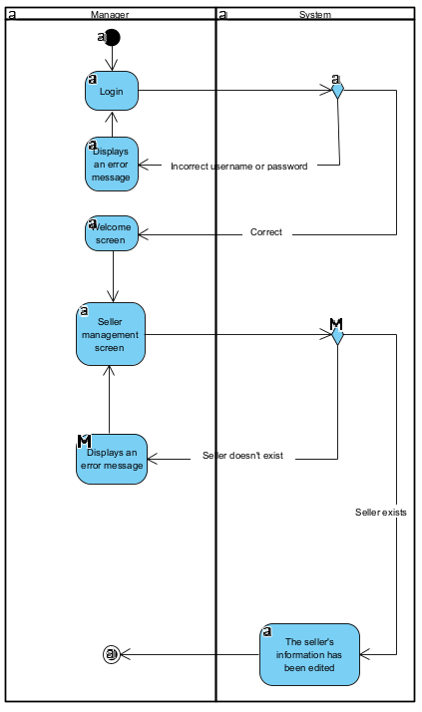

Figure 31: Activity diagram Edit Seller

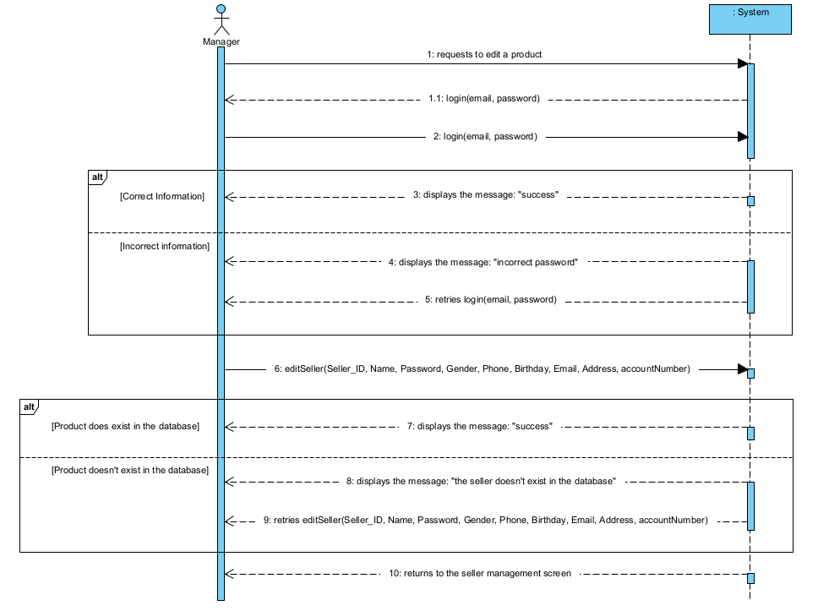

Figure 32: Sequence diagram Edit Seller

### **3.2.15: Delete Seller**

|  |  |  |
| --- | --- | --- |
| **Use Case ID** | UC-15 | |
| **Use Case Name** | Delete seller | |
| **Scenario** | Manager deletes an existing seller on the system | |
| **Actor(s)** | Manager, System | |
| **Priority** | Must have | |
| **Trigger** | Manager clicks on the "delete seller" button | |
| **Pre-Condition(s)** | * Manager wants to delete a seller | |
| **Post-Condition(s)** | * The seller is successfully deleted from the system | |
| **Flow of activities** | Actor | System |
| 1. Manager clicks on the "delete seller" button | 1.1 System shows the seller’s information screen  1.2 System shows the "successfully deleted" message |
| **Non-Functional Requirement** | * The system must run quickly, without errors * System response to user must be quick | |

Table 20: Use Case description Delete Seller

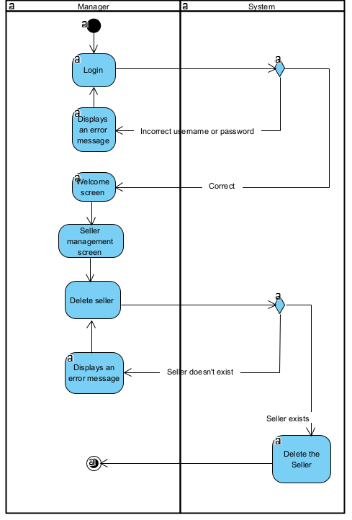

Figure 33: Activity diagram Delete Seller

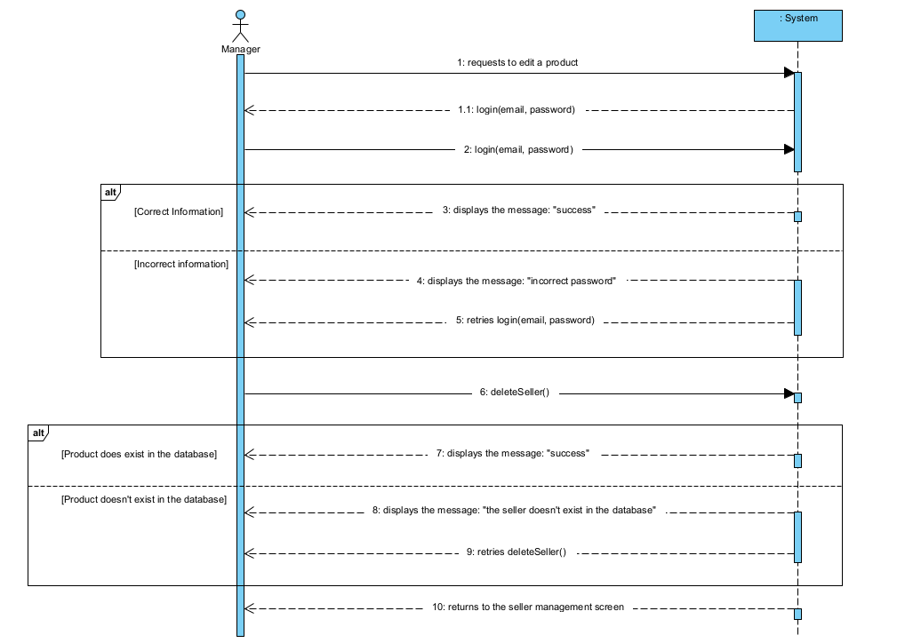

Figure 34: Sequence diagram Delete Seller

### **3.2.16: Create Coupon**

|  |  |  |
| --- | --- | --- |
| **Use Case ID** | UC-16 | |
| **Use Case Name** | Create coupon | |
| **Scenario** | Seller adds new coupon to the system | |
| **Actor(s)** | Seller, System | |
| **Priority** | Must have | |
| **Trigger** | Seller clicks on the "create coupon" button | |
| **Pre-Condition(s)** | * Seller wants to add new coupons | |
| **Post-Condition(s)** | * The coupon is successfully added on the system | |
| **Flow of activities** | Actor | System |
| 1. Seller clicks on the "create coupon " button  2. Seller enters the coupon’s information | 1.1 System shows the coupon information screen  2.1 System saves the new coupon on the database and show "successfully added" message |
| **Non-Functional Requirement** | * The system must run quickly, without errors * System response to user must be quick | |

Table 21: Use Case description Create Coupon

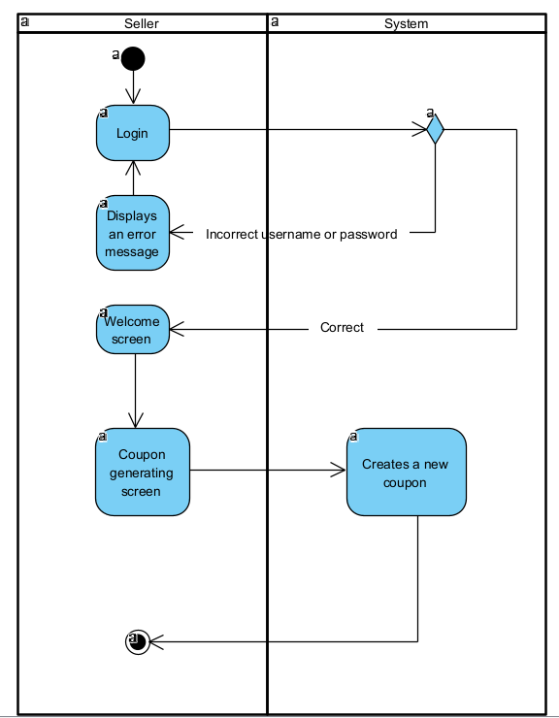

Figure 35: Activity diagram Create Coupon

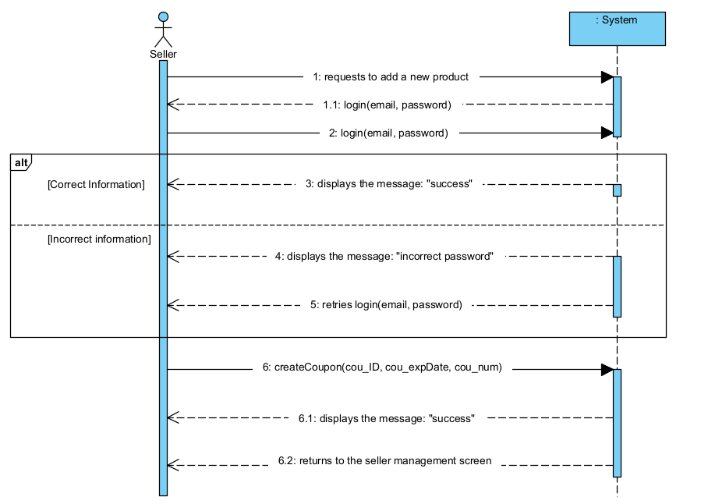

Figure 36: Sequence diagram Create Coupon

### 

## **3.3: Verifying use cases for Actor**

### **3.3.1: Verifying uses cases for Administrator**

|  |  |  |
| --- | --- | --- |
| Data entity/ Domain class | C R U D | Verified use case |
| Adminstrator | Create | Crete backup file |
|  | Read / Report | Search for user |
|  | Update | Update the system |
|  | Delete | Delete users |

Table 22: Verifying uses cases for Administrator

### **3.3.2: Verifying uses cases for Manager**

|  |  |  |
| --- | --- | --- |
| Data entity/ Domain class | C R U D | Verified use case |
| Manager | Create | Crete manager account |
|  | Read / Report | Read information of sellers |
|  | Update | Edit information of sellers |
|  | Delete | Delete information of sellers |

Table 23 : Verifying uses cases for Manager

### **3.3.3: Verifying uses cases for Seller**

|  |  |  |
| --- | --- | --- |
| Data entity/ Domain class | C R U D | Verified use case |
| Seller | Create | Crete sales statistics |
|  | Read / Report | Sales statistics |
|  | Update | Edit information of the product |
|  | Delete | Delete information of the product |

Table 24: Verifying uses cases for Seller

### **3.3.4: Verifying uses cases for Customer**

|  |  |  |
| --- | --- | --- |
| Data entity/ Domain class | C R U D | Verified use case |
| Customer | Create | Create customer account |
|  | Read / Report | Read information product when search to buy |
|  | Update | Edit information of the customer account |
|  | Delete | Update the customer account |

Table 25: Verifying uses cases for Customer

# CHAPTER 4: SYSTEM REQUIREMENT DESIGN

## **4.1: Design Class for Customer Use Cases**

### **4.1.1: Design Classes in Detailed Design**

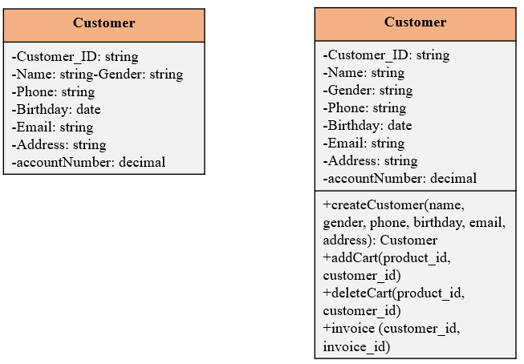

Figure 37: Design Classes in Detailed Design

### **4.1.2: Design Class Diagram**

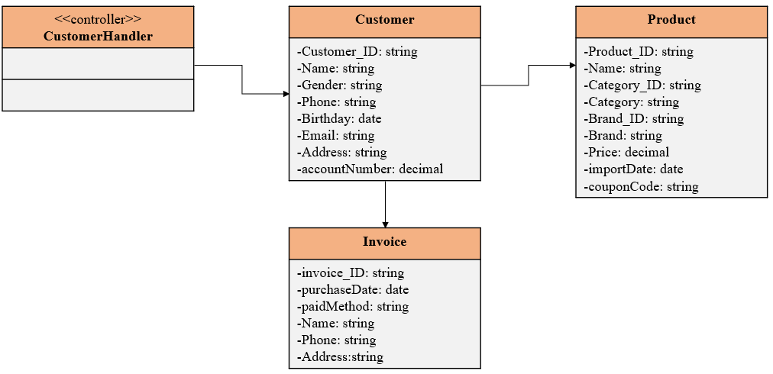

Figure 38: Domain Design Class

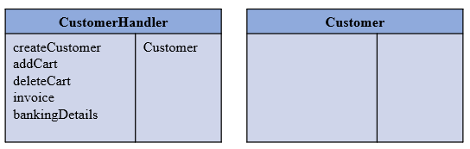

Figure 39: Controller

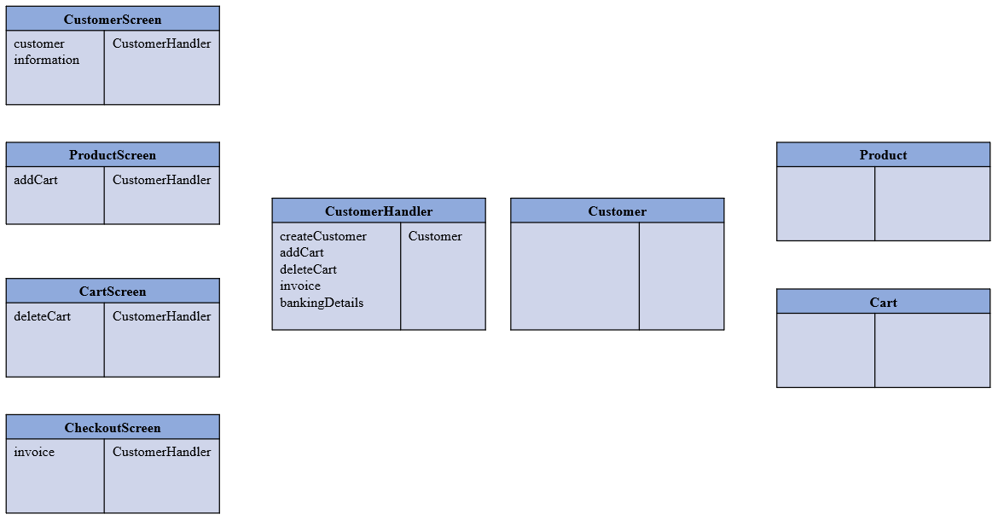

Figure 40: UI

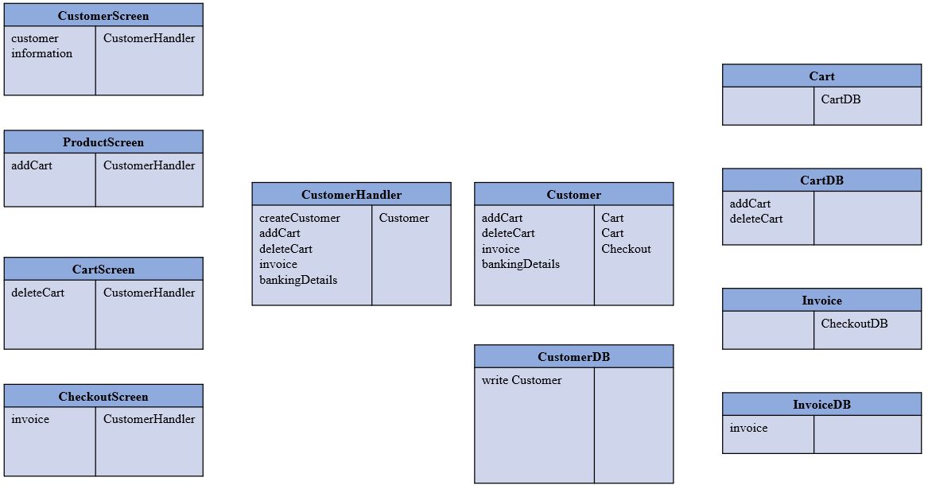

Figure 41: Data Access

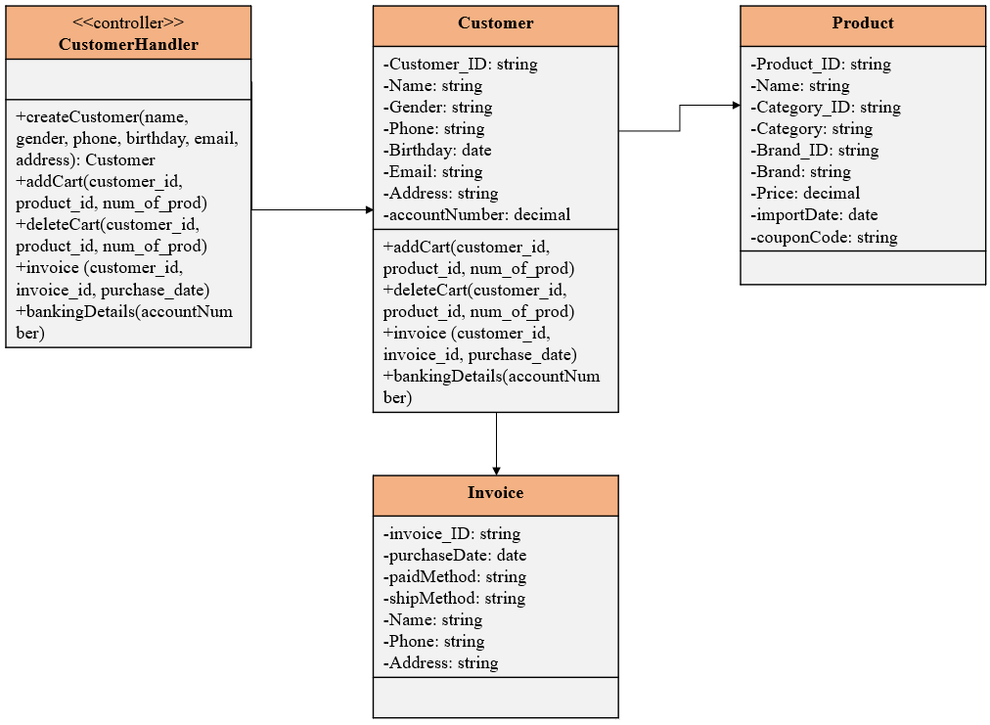

Figure 42: Design Class

### **4.1.3: OOD with Communication**

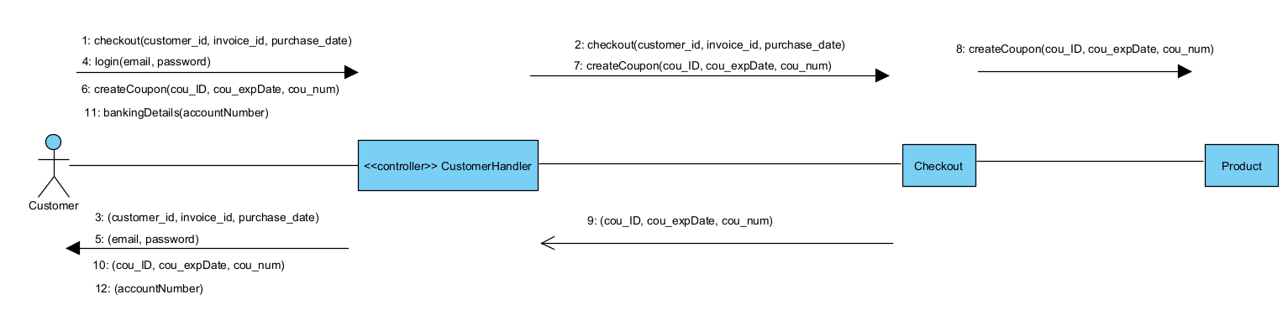

Figure 43: OOD with Communication

### **4.1.4: OOD with Sequence Diagram**

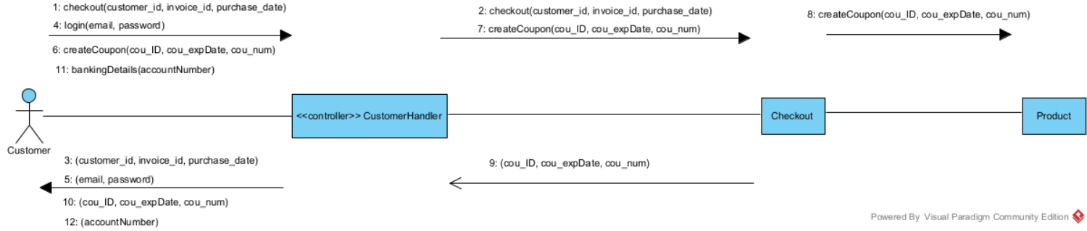

Figure 44: OOD with Sequence Diagram

### **4.1.5: Final Design Class Diagram**

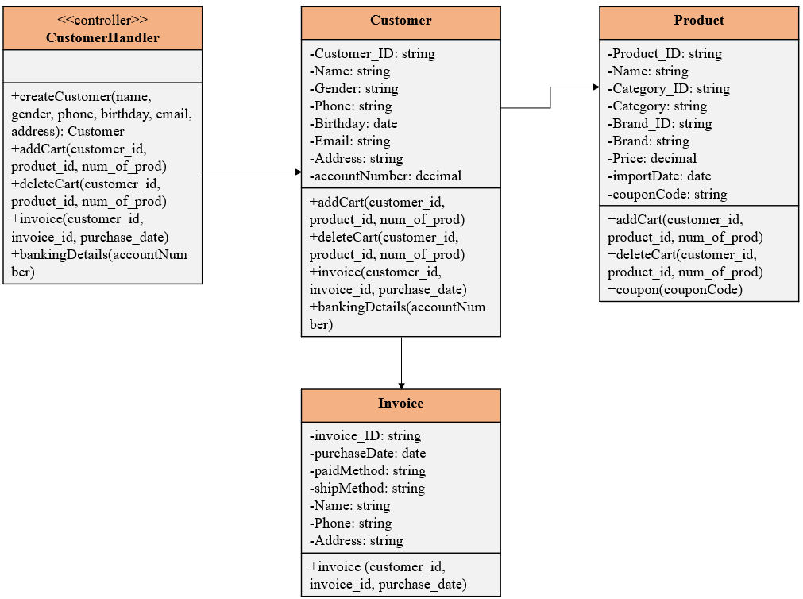

Figure 45: Final Design Class Diagram

## **4.2: Design Class for Seller Use Cases**

### **4.2.1: Design Classes in Detailed Design**

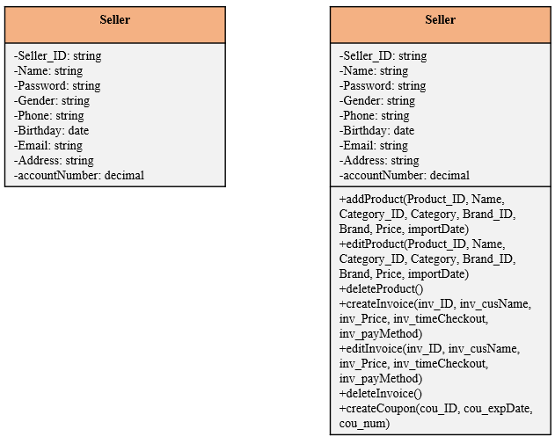

Figure 46: Design Classes in Detailed Design

### **4.2.2: Design Class Diagram**

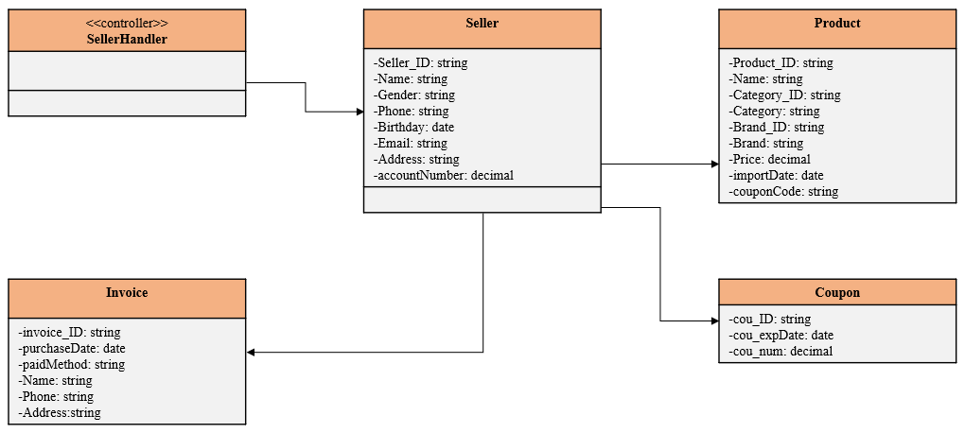

Figure 47: Domain Design Class

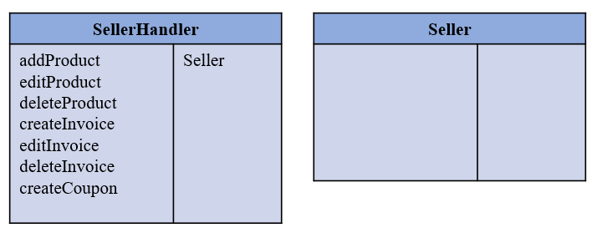

Figure 48: Controller

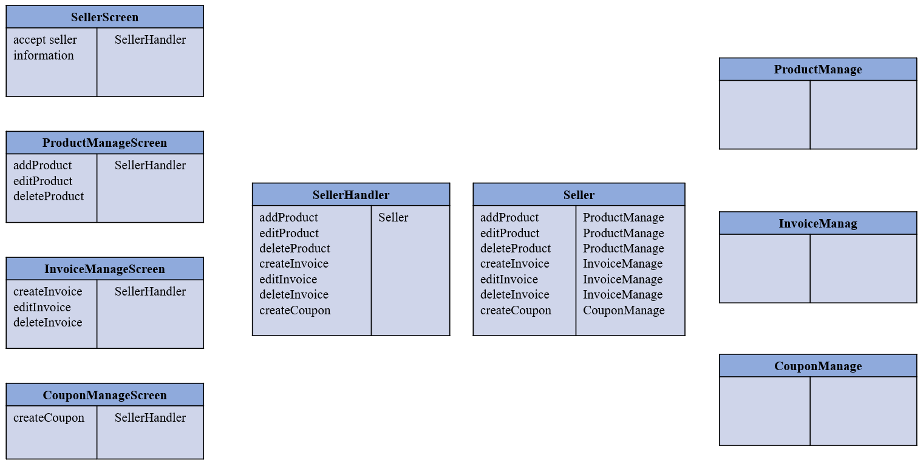

Figure 49 : UI

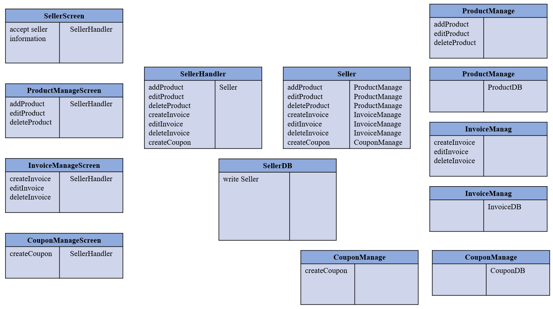

Figure 50: Data Access

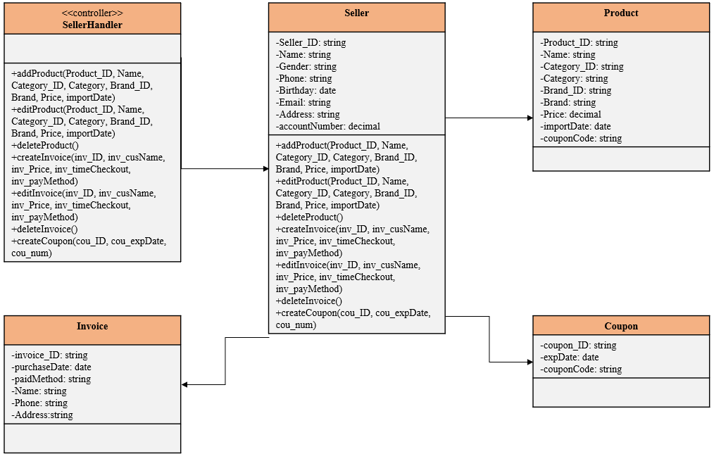

Figure 51: Design Class

### **4.2.3: OOD with Communication**

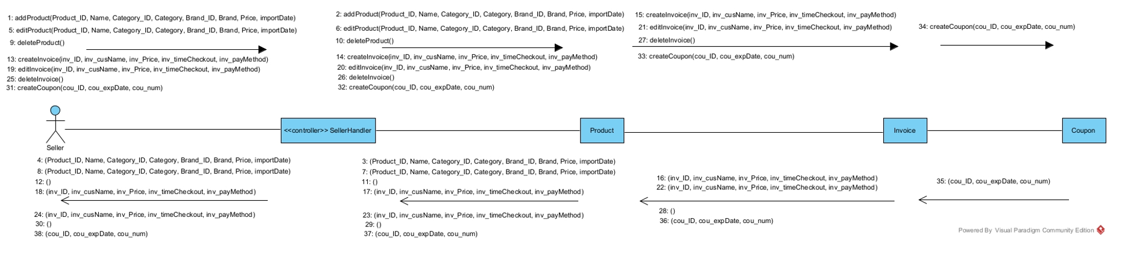

Figure 52: OOD with Communication

### **4.2.4: OOD with Sequence Diagram**

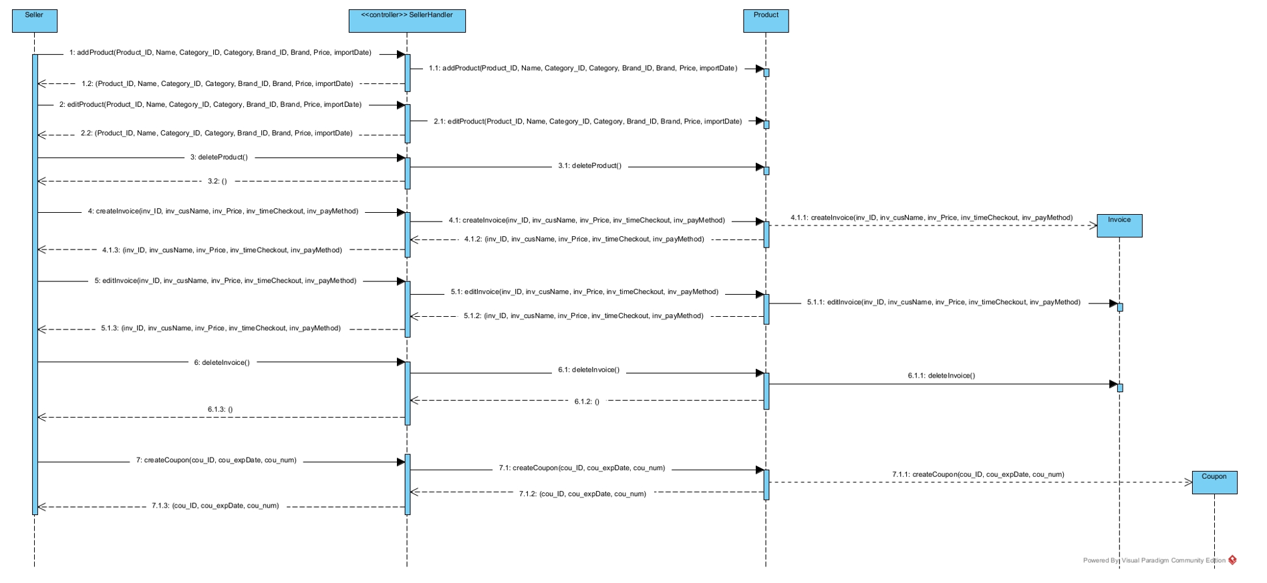

Figure 53: OOD with Sequence Diagram

### **4.2.5: Final Design Class Diagram**

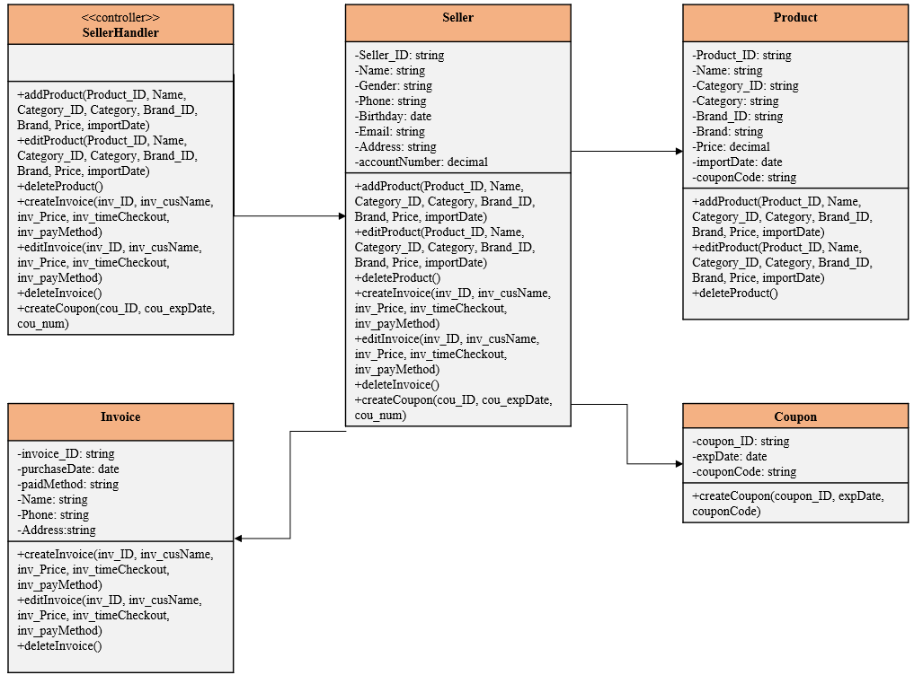

Figure 54 : Final Design Class Diagram

## **4.3: Design Class for Manager Use Cases**

### **4.3.1: Design Classes in Detailed Design**

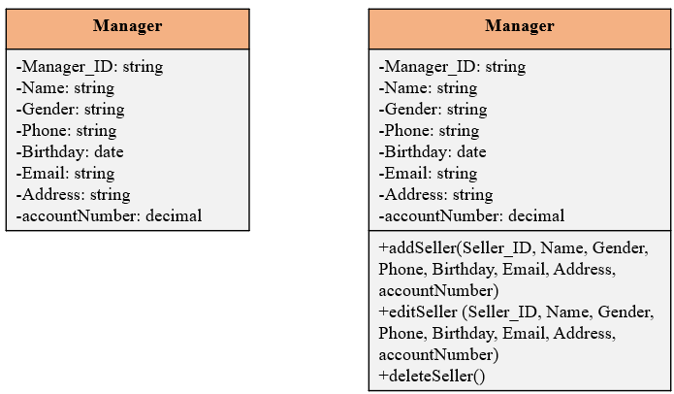

Figure 55: Design Classes in Detailed Design

### **4.3.2: Design Class Diagram**

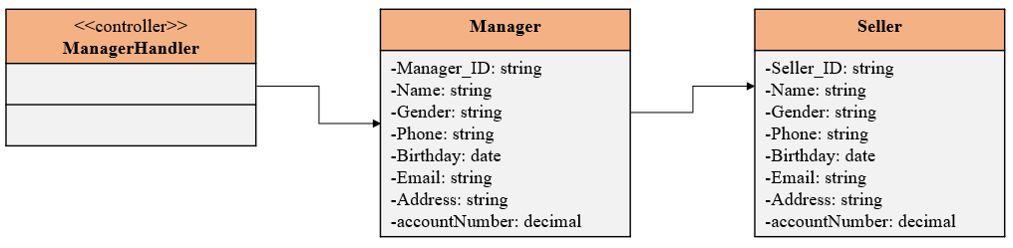

Figure 56: Domain Design Class

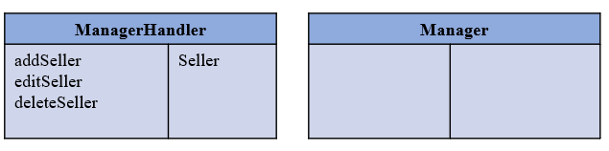

Figure 57: Controller

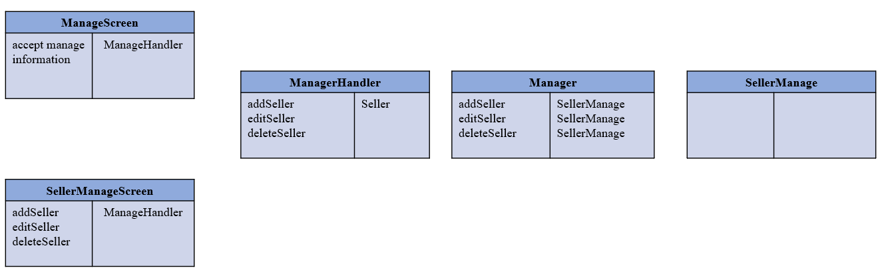

Figure 58: UI

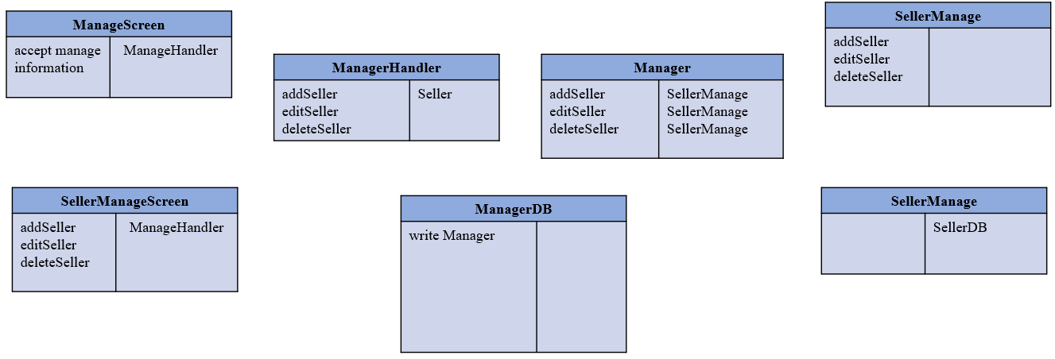

Figure 59: Data Access

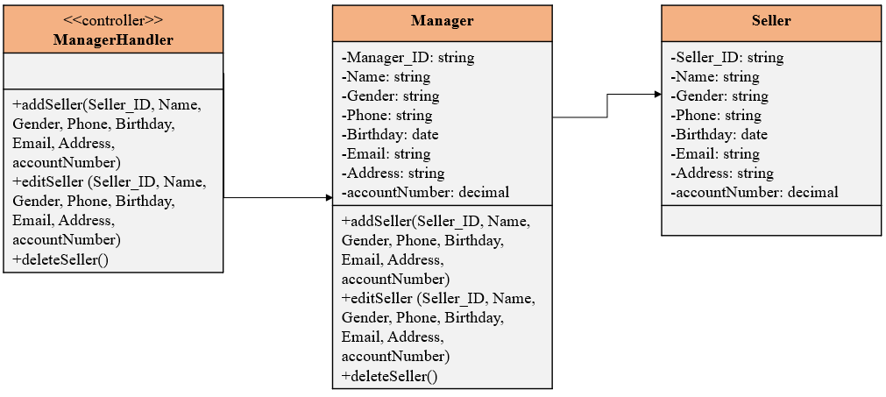

Figure 60: Design Class

### **4.3.3: OOD with Communication**

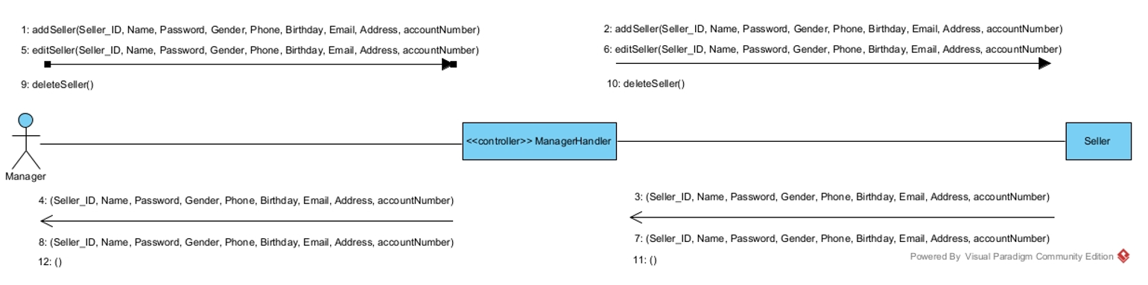

Figure 61: OOD with Communication

### **4.3.4: OOD with Sequence Diagram**

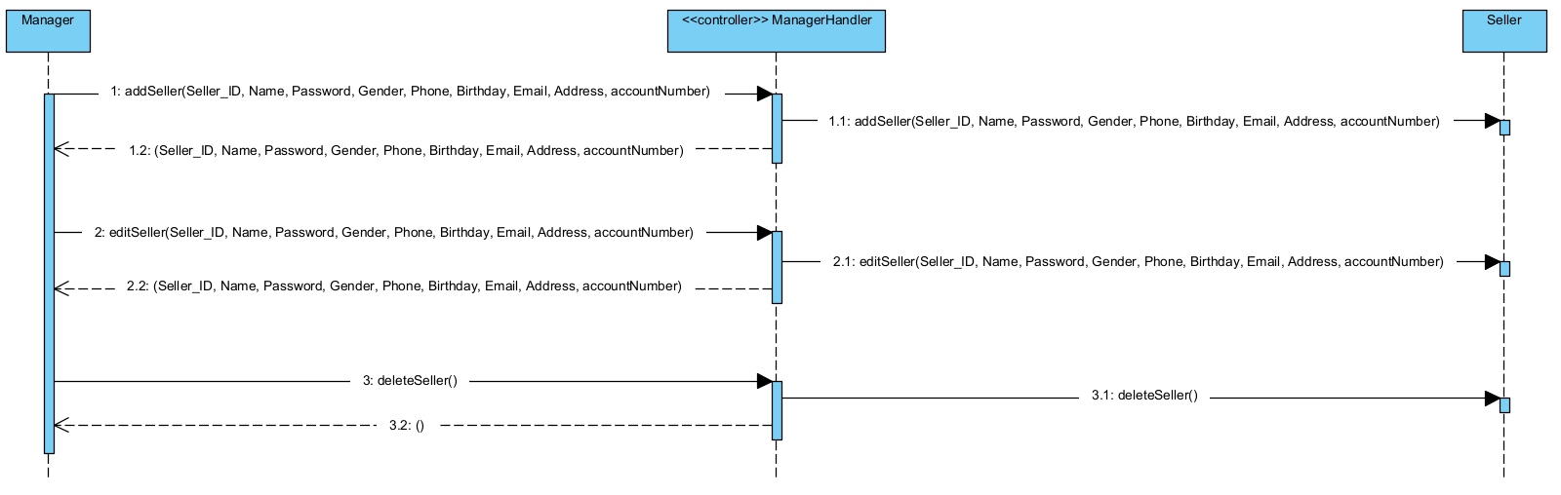

Figure 62: OOD with Sequence Diagram

### **4.3.5: Final Design Class Diagram**

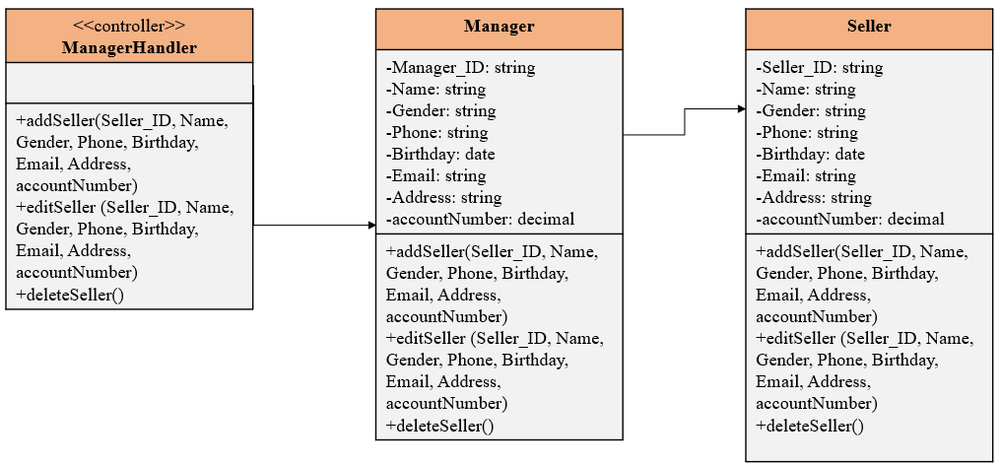

Figure 63: Final Design Class Diagram

# CHAPTER 5: SYSTEM REQUIREMENT IMPLEMENTATION

## **5.1: Design Class for Sub System (Use Cases)**

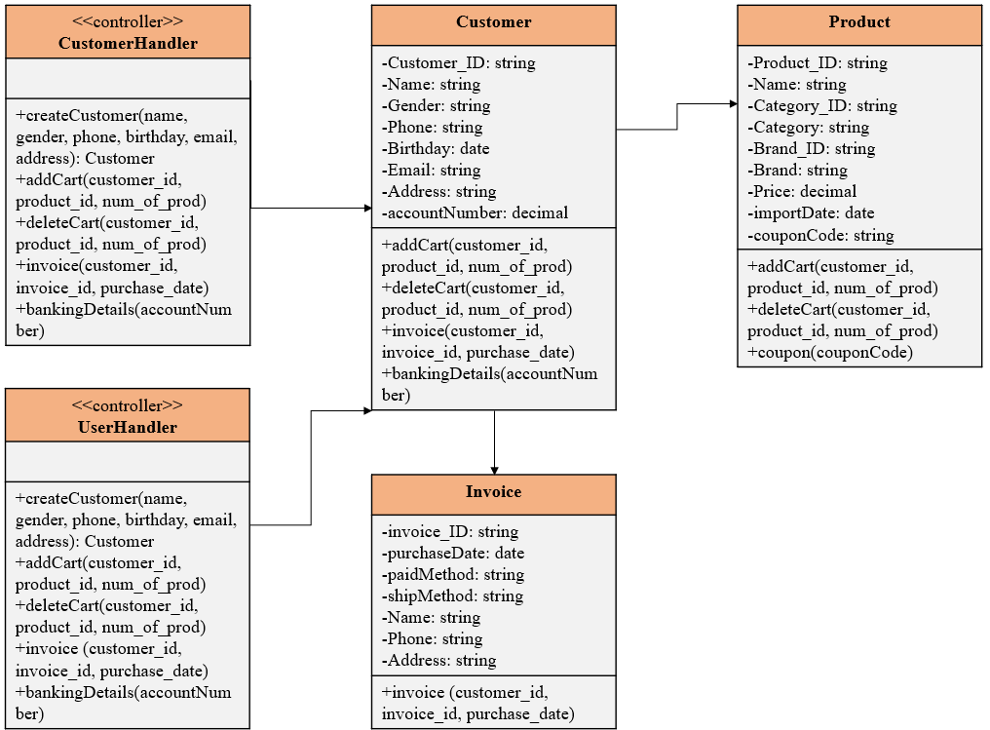

Figure 64: Design Class for Sub System (Use Cases)

## **5.2: Package Diagram for Sub System**

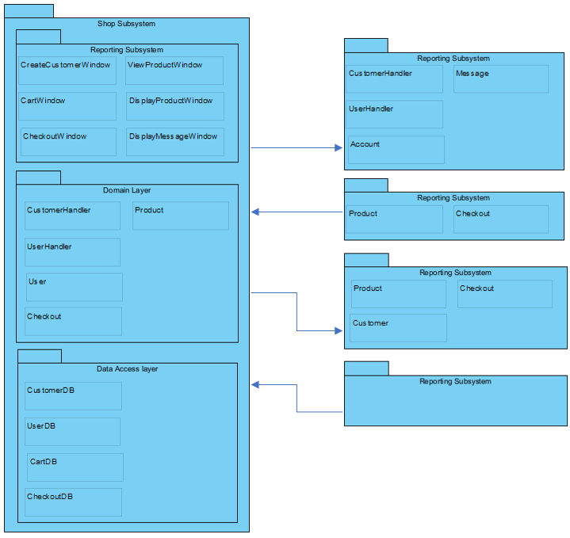

Figure 65: Package Diagram for Sub System

## **5.3: Implementation**

### **5.3.1:** **Map persistent objects to the tables in a database**

### **5.3.2:** **Modifying sequence diagrams**

### **5.3.3:** **UI design**

### **5.3.4:** **SQL Code**

♦ Create Database

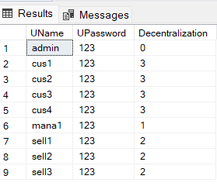

Figure 66: Table Users

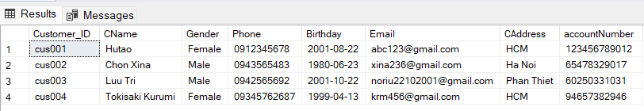

Figure 67 : Table Customer

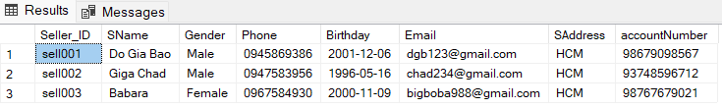

Figure 68: Table Seller

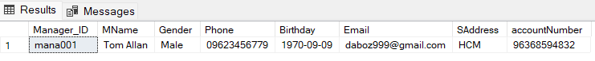

Figure 69: Table Manager

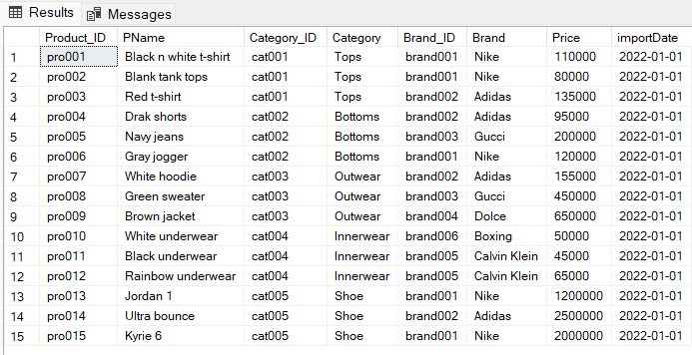

Figure 70: Table Product

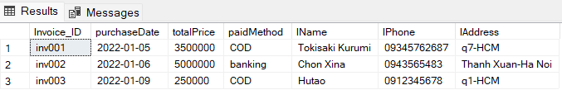

Figure 71: Table Invoice

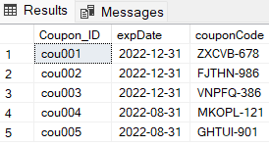

Figure 72: Table Coupon

♦ Create Table

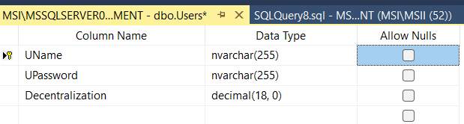

Figure 73: Data of table User

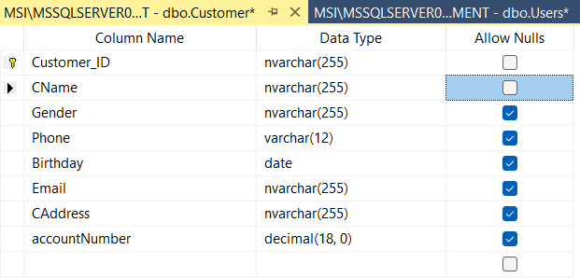

Figure 74 : Data of table Customer

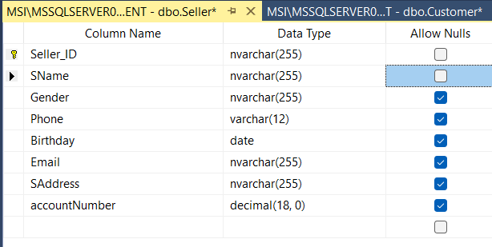

Figure 75: Data of table Seller

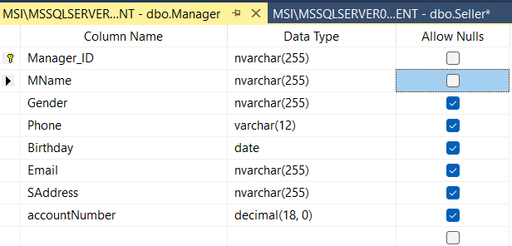

Figure 76 : Data of table Manager

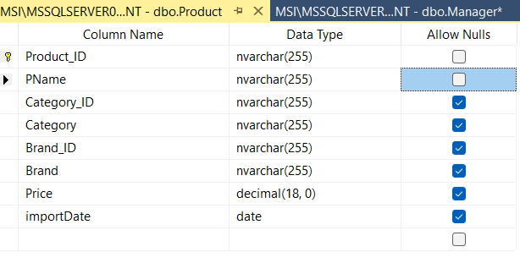

Figure 77 : Data of table Product

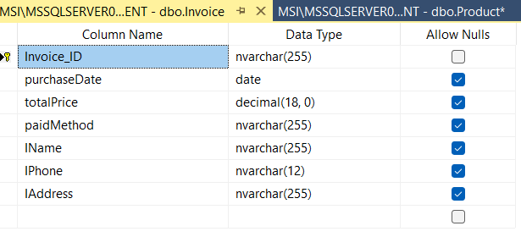

Figure 78 : Data of table Invoice

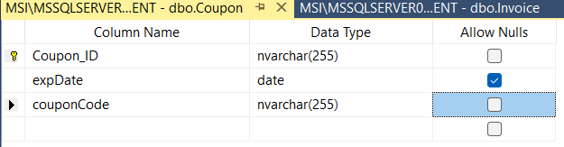

Figure 79: Data of table Coupon

# CHAPTER 6: DEMO

# CHAPTER 7: CONCLUSIONS/RECOMMENDATIONS

Online shop management system is a process of managing not very complicated functions.

The management functions ensure the functions of a online shop.

# CHAPTER 8: REFERENCES

1. https://classroom.google.com/u/0/c/Mzg1OTM2NTQxMDAy/m/NDExODIxNjc0NTE2/details
2. https://www.youtube.com/watch?v=XMpchIp746s
3. https://www.scribd.com/doc/286923085/Online-Shopping-System-Database-Design-Bhupal-Sapkota
4. https://www.uml-diagrams.org/software-licensing-domain-diagram-example.html
5. https://www.lucidchart.com/pages/uml-use-case-diagram
6. Requirements Analysis and Design leture slide provided by Ton Duc Thang University

# CHAPTER 9: APPENDIX

Appendix 1: the full size of use case Diagram



Figure 80: Full size of use case Diagram

Appendix 2: the full size of Class Diagram



Figure 81 : Full size of Class Diagram